

**APTECH GARDEN CENTER**

**E-project**

# **EarthScape**

|  |  |
| --- | --- |
|  |  |

APWA Complex, 1st Floor, Agha Khan 3 Rd, Garden East Saddar Town, Karachi Pakistan.

**EarthScape**

|  |  |  |
| --- | --- | --- |
| Supervisor: | Sir Umer | |
| Project Name | EarthScape | |
| Serial No: | Team-Mate Name: | Enrolment No: |
| 1. | MUHAMMAD ANAS | Student1415086 |
| 2. | MUHAMMAD TAHA | Student1414158 |
| 3. | BHARTI | Student1448007 |
| 4. | ANUM ASGHAR | Student1406511 |

**Contents**

1. Acknowledgement .......................................................
2. Definition of the Problem ...............................................
3. Design Specifications ....................................................
4. Functional Requirements .................................................
5. Diagrams such as User Flow Diagram/User Journey Map ...
6. Test Data Used in the Project ............................................
7. Synopsis ................................................................
8. Designing the Process Modules ......................................
9. Key Features of EarthScape ..............................................
10. Project Installation Instructions ...................................
11. Link of GitHub for accessing the uploaded project code ..
12. Detailed Steps to execute the project ..........................
13. Link of Published...................................................

A**cknowledgement**

In the name of the Most Merciful and Most Benevolent Allah, we present our heartfelt gratitude for guiding us throughout the development of the EarthScape project. His divine wisdom has given us the strength and capability to undertake this challenging and rewarding journey.

We express our deepest thanks to Sir umer, our esteemed supervisor, for his invaluable guidance and support. His insightful feedback and innovative suggestions have been integral to the success of our project.

We also extend our sincere appreciation to our fellow team members and teachers for their cooperation and encouragement throughout this process. Their assistance has created a nurturing environment that allowed us to develop the EarthScape project with clarity and purpose.

A special thank you is due to Aptech Garden Center for providing us with the opportunity to enhance our knowledge and skills through hands-on experiences in software engineering. Their dedication to fostering talent has been critical in helping us evolve into capable professionals, prepared for future challenges in the tech industry.

Finally, we recognize the hard work and dedication of our team members, Muhammad Shawaiz And UbaidUllah whose collaboration and steadfast effort have made EarthScape a reality. Together, we have created something that truly reflects our collective vision, and we are excited to see where this journey will lead us next.

**Synopsis**

EarthScape is an innovative project aimed at addressing the challenges of climate change in agriculture by harnessing the power of data science and big data analytics. As climate change threatens global food security with unpredictable weather patterns, changing growing seasons, and soil degradation, EarthScape offers a comprehensive solution to help farmers, policymakers, and agricultural stakeholders make informed decisions for sustainable farming.

The project focuses on predictive modeling to forecast crop yields based on environmental factors such as temperature, rainfall, and solar radiation. By integrating machine learning models like Random Forest Regressor, Support Vector Regressor (SVR), and Naive Bayes, EarthScape analyzes large datasets to provide real-time insights into agricultural practices. This helps farmers adapt to climate-related challenges and optimize their crop production.

The Random Forest Regressor and SVR are used for regression tasks, predicting continuous crop yield values based on input features.

The Naive Bayes model is used to classify crop yield data by categorizing the target variable into different bins.

EarthScape’s process includes data collection, cleaning, pre-processing, and storage using Excel and Python tools. Advanced visualization techniques are employed using Tableau to make data accessible and actionable. With an emphasis on regional agricultural challenges, the platform offers tailored solutions for farmers in diverse climates, supporting both small-scale and large-scale agricultural systems.

By leveraging data science for predictive analytics, EarthScape empowers farmers to navigate climate uncertainty, improve resilience, and maintain food security while promoting environmentally sustainable practices. Through its user-friendly interface and automation, EarthScape makes advanced data-driven tools available to even those with limited technical expertise, contributing to a more sustainable future for global agriculture.

**Key Features of EearthScape**

The EarthScape project encompasses a range of essential features designed to address the challenges posed by climate change on agriculture, ensuring a sustainable approach for farmers and stakeholders. Below are the core functionalities:

**Integrating Django with Streamlit: A Seamless Connection**

This document outlines the step-by-step process of integrating Django—a robust backend web framework—with Streamlit, a Python-based interactive front-end tool. This connection bridges the power of a secure backend with a user-friendly and dynamic front-end interface, enabling advanced features such as user authentication, real-time data sharing, and dynamic data visualization.

Below, we detail the tools used, the implementation steps, and the outcomes achieved through this integration.

**Objective**

The integration successfully achieves the following:

1. **Authenticate Users**: Manage secure login and logout functionality through Django.
2. **Real-Time Data Exchange**: Allow Python (Streamlit) to interact with Django’s backend for user-specific data retrieval and processing.
3. **Dynamic Data Display**: Provide real-time, user-specific insights and visualizations through Streamlit’s interactive interface.
4. **Seamless Interaction**: Establish a robust communication pipeline between Django and Streamlit, effectively connecting two distinct languages—backend web development with interactive Python tools.

**Process Overview**

**1. Connecting Django and Streamlit**

The integration of Django and Streamlit combines their unique strengths:

* **Django**: Handles secure data management, user authentication, and real-time API responses.
* **Streamlit**: Serves as an interactive front-end application that fetches data from Django’s backend and visualizes it dynamically for the user.

**2. Django Backend Setup**

**A. User Authentication (Login and Logout)**

**Login**:

* Users provide their email and password, which Django verifies.
* If valid, Django creates a user session and redirects to the dashboard.
* If invalid, an error message is displayed to the user.

**Logout**:

* User sessions are securely terminated using Django’s logout functionality.
* The user is redirected to the login page with a confirmation message.

This ensures that Django manages the entire authentication process securely while Streamlit interacts only with authenticated data.

**3. Real-Time Data Sharing Between Django and Streamlit**

To enable Streamlit to fetch data dynamically, Django exposes an API endpoint. This API:

* Accepts user-specific requests (e.g., email).
* Retrieves relevant data from Django’s database.
* Responds in real time, allowing Streamlit to display the information immediately.

This communication bridges the two systems, effectively connecting a backend web language with a Python-based visualization tool.

**Outcome of Integration**

By connecting Django with Streamlit, we achieved:

1. **Cross-Language Communication**:
   * Django acts as the secure backend handling authentication and data storage.
   * Streamlit serves as the interactive front-end, fetching and visualizing data.
2. **Dynamic User Experience**:
   * Users interact with real-time data on Streamlit while Django securely processes and provides the required data.
3. **Seamless Workflow**:
   * The integration leverages Django’s backend power with Streamlit’s user-friendly interface, creating a cohesive and scalable application.

**1. User Authentication**

* **Login and Signup Functionality:**
  + **Secure Signup:**
* Users can register with a unique email and password.
* Passwords are hashed using Django’s authentication system for security.
  + **Login System:**
* Registered users can log in with their credentials.
* Login sessions are managed using Django's session framework.

**2. Raw Data Collection**

- Comprehensive Data Gathering: Collect data on environmental factors such as temperature, rainfall, and solar radiation, alongside crop production statistics from reliable sources.

The dataset was cleaned and sorted using Python before modeling, ensuring that non-numeric columns and irrelevant data were removed. This process was performed in Python to streamline data preparation, instead of manually handling it in Excel, making the pipeline more efficient and reproducible.

**3. Data Storage and Management**

- Organized Data Handling: Utilize organized data storage in Excel to manage and update datasets effectively, ensuring easy access for analysis.

**4. Data Pre-Processing**

- Data Readiness: Prepare data for analysis by addressing missing values and standardizing formats, ensuring it is primed for accurate model training.

**5. Machine Learning Models**

* Split the dataset into training and testing sets (80% training and 20% testing).
* Three models are used:
  + Random Forest
  + SVM (Support Vector Machine)
  + Naive Bayes (used with binned target data).

**6. Model Evaluation:**

* For each model, predictions are made on the test set.
* Metrics used to evaluate models:
  + **MAE** (Mean Absolute Error)
  + **MSE** (Mean Squared Error)
  + **RMSE** (Root Mean Squared Error)
  + **R²** (Coefficient of Determination).
* Results are stored in a Data Frame and printed.

**7. Prediction and Output Generation**

- Forecasting Capabilities: Generate predictions that help users understand crop yields and make informed decisions based on data-driven insights.

**8. Result Visualization**

Insightful Data Representation: Utilize data visualization techniques to represent model performance and predictions clearly, aiding interpretation for stakeholders.

**9. Real-Time Data Visualization**

**Description:**The Real-Time Data Visualization feature displays data updates dynamically in real-time. It is designed to monitor key metrics and visualize trends over time for informed decision-making.

**Key Features:**

* **Dynamic Updates:**

Continuously fetches or simulates new data points.

* **Interactive Charts:**

Visualizes real-time data using line charts or other graphical representations.

* **Threshold Monitoring:**

Integrateswith Notifications and Alerts to highlight anomalies in visualizations.

**Implementation:**

* **Simulated Data:**

For demonstration, the system generates or uses mock data for metrics like timestamp and value.

* **Real-Time Updates:**

The data refreshes automatically at regular intervals (e.g., every second).

* **Visualization:**

Displays the updated data in an interactive line chart and as a table.

**10. Notifications and Alerts**

* **Description**:  
  The Notifications and Alerts feature enables real-time monitoring of data for anomalies or significant events. Based on
* **Threshold-Based Alerts**: Sends warnings if values exceed the defined limits.
* **Email Notifications**: Automatically sends email alerts to stakeholders when thresholds are breached.

**Implementation**:

* Users can set thresholds (e.g., maximum temperature) using sliders.
* If a data point crosses the threshold, the system:
  1. Displays a warning in the dashboard.
  2. Sends an email notification to the registered email address.

**11. System Integration**

Seamless Workflow: Ensure a cohesive integration of all components, from data collection to analysis and visualization, promoting an efficient and streamlined process.

**12. User Interface**

User-Friendly Access: Provide an intuitive interface that allows users to input data, choose visualization options, and view results interactively, making it accessible even for those with limited technical expertise.

**13. Feedback and Support**

* **User Feedback:**
  + Provide feedback forms for users to suggest improvements or report issues.

**14. Feedback Form**

**Description**:  
The Feedback Form allows users to provide their feedback or report issues directly through the dashboard.

**Key Features**:

* **User Input Fields**: Includes fields for name, email, and feedback details.
* **Email Integration**: Automatically sends feedback to the administrator's email.
* **Data Storage**: Saves feedback locally in a CSV file for record-keeping.

**Implementation**:

* Users fill out a simple form within the dashboard.
* Upon submission:
  1. Feedback is sent via email.
  2. A confirmation message is displayed to the user.
  3. The feedback is optionally stored in a local CSV file.

At EarthScape, we are dedicated to employing advanced data science techniques to empower farmers and agricultural stakeholders. By leveraging technology and data analytics, we strive to provide innovative solutions that promote sustainable practices and ensure food security in the face of climate change.

**Functional Requirement**

Customer Requirements for EarthScape

With the increasing awareness of sustainable agricultural practices amid climate change, there is a growing demand for data-driven solutions that can assist farmers and agricultural stakeholders in making informed decisions. The EarthScape project addresses these needs through innovative data science methodologies that help manage agricultural activities effectively. Below are the core requirements:

**User Requirements:**

1. **Data Entry and Management:**

As a user, I want to input data related to environmental factors, crop yields, and other metrics to effectively monitor and manage agricultural activities.

I want to ensure my data entries are secure and can be updated or edited when necessary.

1. **Accessibility:**

As a user, I need access to the EarthScape platform at all times, which requires a reliable internet connection to view real-time insights and predictions.

The platform should support multiple devices (desktop, tablet, and mobile) for ease of access.

1. **Data Visualization:**

As a user, I want to visualize my agricultural data through interactive charts and graphs, enabling me to track progress and make informed decisions over time.

I want real-time visualizations that update dynamically as new data is added, helping me monitor ongoing activities.

1. **Prediction and Recommendations:**

As a user, I want to receive tailored predictions and recommendations based on my input data, helping me adapt my practices to changing environmental conditions.

I need these insights to be clear, actionable, and aligned with my specific goals.

1. **5. Notifications and Alerts:**

As a user, I want to receive real-time notifications when critical thresholds (e.g., temperature, humidity) are exceeded, helping me respond quickly to environmental changes.

I need customizable alert settings to align notifications with my specific monitoring requirements.

1. **Feedback and Support:**

As a user, I want a seamless way to provide feedback on the platform's performance or report issues to developers.

I need a support system to help resolve technical issues or guide me through platform functionalities.

**Developer Requirements:**

1. **Feedback and Support:**

As a developer, I must create an intuitive and accessible user interface that allows users to interact with the system easily and understand its functionalities.

The UI must support responsive design to ensure compatibility across devices and screen sizes.

1. **Feature Visibility:**

As a developer, I need to ensure clear visibility of all features, including buttons, data visualizations, and real-time monitoring, to facilitate a seamless user experience.

1. **Data Processing Algorithms:**

As a developer, I need to implement algorithms that effectively process input data, ensuring accurate predictions and insights are generated for users.

Algorithms should be optimized for handling large datasets efficiently while maintaining accuracy.

1. **Core Functionality Mapping:**

As a developer, I must map all core functionalities needed by users, ensuring that the EarthScape platform meets the diverse needs of farmers and agricultural stakeholders.

1. **Real-Time Data Visualization:**

As a developer, I must implement real-time data visualization tools, such as line charts and tables, that dynamically update as new data points are received.

The visualizations should integrate seamlessly with the notification system to highlight anomalies or critical thresholds.

1. **Notifications and Alerts:**

As a developer, I need to implement a robust alerting mechanism that triggers notifications based on user-defined thresholds for key metrics like temperature and humidity.

Email notifications must be reliable, secure, and sent in real-time to alert users promptly.

1. **Feedback and Support System:**

As a developer, I must create a feedback system that stores user inputs securely, enabling developers to track and address issues effectively.

The support system should also allow automated acknowledgment emails to ensure users know their feedback has been received.

**Requirement Analysis**

Here's how the elements in your requirement analysis for EarthScape align with the project's components:

* **Inputs to the System**

**1. User Interaction:**

Users interact with various functionalities of the EarthScape platform, including navigation, input forms for agricultural data, and links to reports.

**2. Agricultural Data Input:**

Users input data related to crop yields, environmental conditions (temperature, rainfall), and health metrics (e.g., soil quality).

**3. Report Generation**

In the Generate Report section of the EarthScape Data Analysis Dashboard, users can easily download the filtered data they have processed. This feature allows for seamless exporting of data in both CSV and Excel formats, enhancing the usability of the application.

**Key Features:**

* **Download as CSV**:

Users can click the "Download Report as CSV" button to export the current filtered dataset in CSV format. This is particularly useful for those who prefer working with data in spreadsheet applications or for further analysis.

* **Download as Excel**:

Users have the option to download the data as an Excel file by clicking the "Download Report as Excel" button. This allows for better formatting and the ability to utilize Excel's advanced features.

**Usage:**

1. **Filtered Data Requirement**:

Before generating a report, users must first upload or enter their data and apply any desired filters. The report will be generated based on the currently displayed filtered dataset.

1. **Download Links**:

Once the user clicks on the respective download button, a link will be generated. Clicking this link will initiate the download of the report in the chosen format.

* **Outputs Expected from the System**

**1. Access to Health and Environmental Reports:**

Users can view detailed reports about crop health, soil quality, and weather conditions impacting their agriculture.

**2. View Agricultural History:**

Users can access logs of past agricultural activities, including planting dates and crop types.

**3. View Predictions and Recommendations:**

The system provides tailored predictions based on input data, helping users make informed decisions.

**4. Monitor Progress:**

Users can visualize their progress toward agricultural goals through charts and graphs, tracking metrics like crop yields and environmental conditions.

These elements highlight how EarthScape functions to meet user needs in the context of sustainable agriculture, focusing on data input and actionable outputs.

**5. Report Generation**

In the Generate Report section of the EarthScape Data Analysis Dashboard, users can easily download the filtered data they have processed. This feature allows for seamless exporting of data in both CSV and Excel formats, enhancing the usability of the application.

**Key Features:**

* **Download as CSV**:

Users can click the "Download Report as CSV" button to export the current filtered dataset in CSV format. This is particularly useful for those who prefer working with data in spreadsheet applications or for further analysis.

* **Download as Excel**:

Users have the option to download the data as an Excel file by clicking the "Download Report as Excel" button. This allows for better formatting and the ability to utilize Excel's advanced features.

**Usage:**

1. **Filtered Data Requirement**:

Before generating a report, users must first upload or enter their data and apply any desired filters. The report will be generated based on the currently displayed filtered dataset.

1. **Download Links**:

Once the user clicks on the respective download button, a link will be generated. Clicking this link will initiate the download of the report in the chosen format.

**Hardware and software required for implementing the project**

EarthScape: Leveraging Data Science for Sustainable Agriculture

**Overview:**

EarthScape is a data-driven project designed to support sustainable agriculture in the face of climate change. By utilizing advanced data science and big data analytics, it aims to predict crop yields and provide actionable insights to farmers and agricultural stakeholders.

* **Key Components:**

**1. Raw Data Collection:**

* Collects environmental data (temperature, rainfall, solar radiation) and crop production statistics.
* Data is imported into Excel for cleaning and inspection, addressing missing values and errors.
* The dataset was cleaned and sorted using Python before modeling, ensuring that non-numeric columns and irrelevant data were removed. This process was performed in Python to streamline data preparation, instead of manually handling it in Excel, making the pipeline more efficient and reproducible.

**2. Data Storage and Management:**

* Organizes and stores data in Excel, using version control for updates.
* Cleaned data is exported for further analysis in Python or other tools.

**3. Data Pre-Processing:**

* Involves standardizing formats and consolidating multiple data sources into a single Excel sheet, ensuring readiness for machine learning model training.

**4. Machine Learning Models:**

* **Random Forest Regressor**: This model is applied for regression tasks, predicting continuous values based on the relationships between input features. In this code, the Random Forest model predicts the target variable, Normalized Values, by constructing multiple decision trees and averaging their predictions.
* **Support Vector Regressor (SVR)**: Another model used for regression; SVR aims to predict continuous values by finding the best fit between data points while maintaining a margin of error.
* **Naive Bayes Classifier**: Although Naive Bayes is traditionally used for classification, in this code, the target variable is binned into categories using pd.qcut() to allow the Naive Bayes model to perform categorical classification on the continuous Normalized Values.

**Model Evaluation:**

The models are trained on the provided data, and their performance is evaluated using the following metrics:

* **Mean Absolute Error (MAE)**: Measures the average magnitude of the errors in predictions.
* **Mean Squared Error (MSE)**: Calculates the average squared difference between actual and predicted values.
* **Root Mean Squared Error (RMSE)**: Provides insight into the error magnitude, being the square root of the MSE.
* **R² (Coefficient of Determination)**: Evaluates how well the models explain the variance in the data, where a value of 1 indicates perfect prediction and 0 means no predictive power.

**5. Prediction and Output Generation:**

* Generates predictions, visualized in user-friendly formats for easy interpretation.

**6. Result Visualization:**

* Utilizes bar charts and metrics like mean squared error (MSE) to represent model performance and outcomes.

**7. System Integration:**

* Ensures seamless integration of components, automating workflows for efficiency.

**8. User Interface:**

* Features a Python-based interface that allows users to input data and view results interactively.

**Impact on Agriculture:**

EarthScape tailors’ solutions to regional challenges posed by climate change, empowering farmers—especially small-scale farmers—to adapt practices and improve resilience.

**Conclusion:**

By combining advanced data science techniques and region-specific insights, EarthScape empowers farmers to optimize crop yields and ensure sustainable agricultural practices, addressing the urgent need for food security amidst climate challenges.

Technologies Used:

* Data Storage: CSV file format for compatibility.
* Programming: Python, developed in Jupyter Notebook and Anaconda.
* Data Analysis: Leveraging pandas for data manipulation.
* Visualization: Tableau Desktop for interactive data representations.

**Designing the Process Modules**

Sure! Here’s a refined version of your content with a focus on clarity and cohesion:

**Designing the Process Modules**

A software process module is a collection of procedures for defining, creating, implementing, and testing software systems. An abstract representation of a process that provides insight from a specific perspective is known as a software process model. Despite the variety of software processes, they generally include the following key activities:

* **Specification**: Defining what the system should do or perform.
* **Design and Implementation**: Organizing the system and executing the implementation.
* **Evolution**: Adapting the system in response to changing customer needs or requirements.

Among various software models, Agile methodology has gained significant popularity, especially for its adaptability and responsiveness to change. Within Agile, we adopted Scrum to develop our website.

**Agile Process Methodology:**

Agile encompasses a variety of techniques and procedures based on the principles outlined in the Agile Manifesto. It fosters a mindset that enables organizations and teams to innovate, swiftly adapt to changing market conditions, and minimize risks. Various frameworks exist under the Agile umbrella, including Extreme Programming (XP), Scrum, Kanban, and Lean, each promoting agility in unique ways.

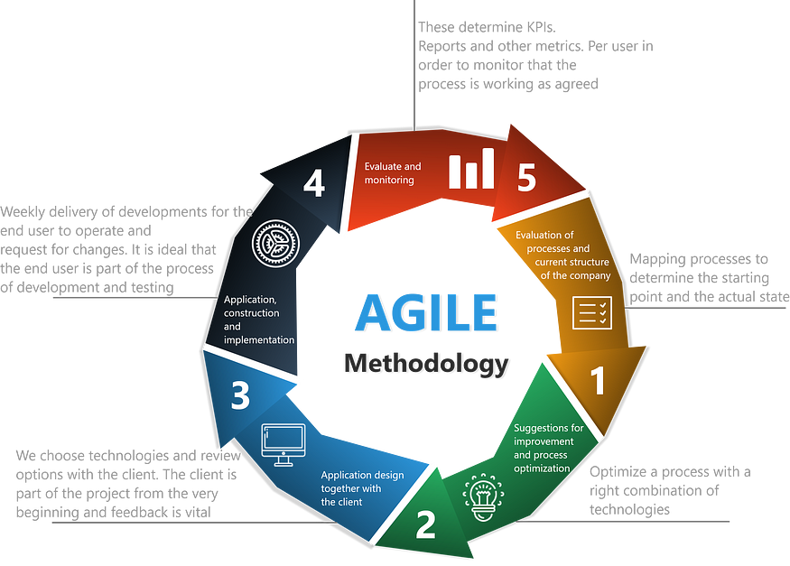

**Scrum**

Scrum is an Agile methodology focused on management and collaboration to achieve shared objectives. It provides a framework comprising defined roles, meetings, and resources essential for effective project delivery. Similar to a sports team preparing for a crucial match, Scrum practices empower teams to self-manage, learn from experience, and adapt to changes dynamically.

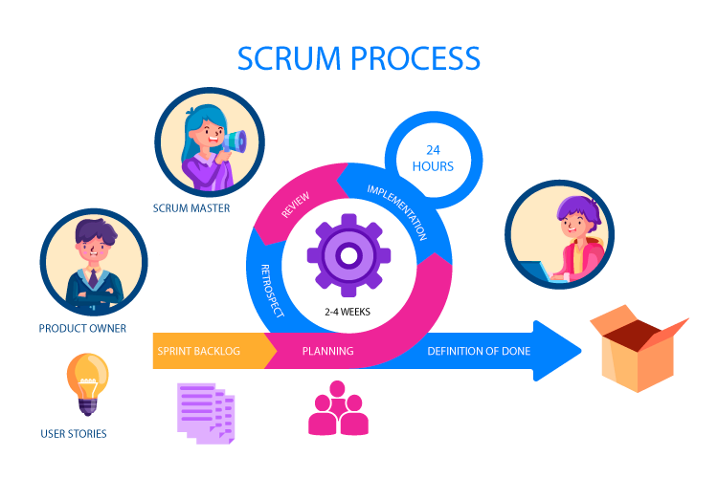

**Non-Functional Requirements**

**Performance:**

**Response Time:**

* The website can respond to user interactions within seconds for most operations. The websites provide user to access and add functionalities, the user can achieve their desire products on time.

**Scalability:**

* The website can handle a growing number of users and data without any performance degradation or any other issues. The system is design in a way that it can easily handles any request and perform operations successfully.

**Concurrent Users:** The website is capable to handle should support hundreds of concurrent users without performance bottlenecks.

**Reliability:**

**Uptime:**

* Website is maintained and running up all time where user can access it any time when they want to access it and we aim for our site to maintain minimum of 99% uptime, with scheduled maintenance time to time communicated in before the certain deadline.

**Usability:**

**User Interface Design:**

* website is designed very interactive, no complex features simple, user-friendly interface with consistent navigation and a responsive design that works on various devices due to which it is easy to use for everyone

**Accessibility:**

* The website is accessibility for every time which can usable by individuals with disabilities.

**Compatibility:**

**Cross-Browser Compatibility:**

* The website is capable of handling cross browser function correctly on popular web browsers, including Chrome, Firefox, Safari, and Edge. User will not face any problem when running on any browser because it is designed and capable of cross-browser handling.

**Mobile Compatibility:**

* Our website now offers seamless responsiveness across all screen sizes, ensuring optimal user experience on mobile devices. Access your fitness journey on-the-go with ease and convenience.

**Scalability:**

**Horizontal Scalability:**

* The website is architecture can easy support horizontal scaling to accommodate increased user loads as the user base grows, including Chrome, Firefox, Safari, and Edge.

**Performance Monitoring:**

**Testing and Quality Assurance:**

* website is test and verify that every user requirement’s is handled and test properly by our team. So, that the user can enjoy it features easily without facing any issue or lags.

**Test Coverage:**

* We have performed comprehensive test suite should be maintained, covering unit testing, integration testing, and end-to-end testing which needs to follow as per software guides in which we have tested all test cases created and cover every scenario which arises.

**Designing Phase**

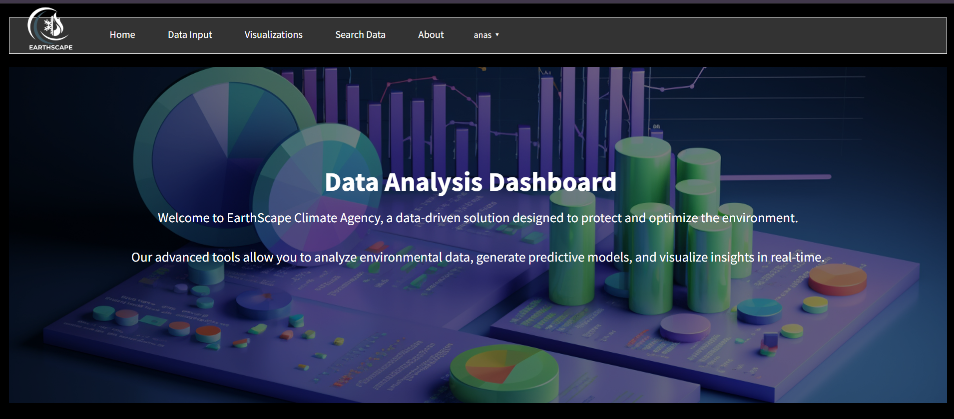

**EarthScape Futuristic Data Analysis Dashboard**

**1. Home Section**

The Home Section serves as the introductory gateway to the EarthScape platform. It welcomes users with an engaging overview, highlighting the mission of the dashboard: to provide a data-driven solution for environmental protection and optimization. The text emphasizes the dashboard's capability to analyse environmental data, generate predictive models, and visualize insights in real-time, making it a powerful tool for users looking to make informed decisions based on data.

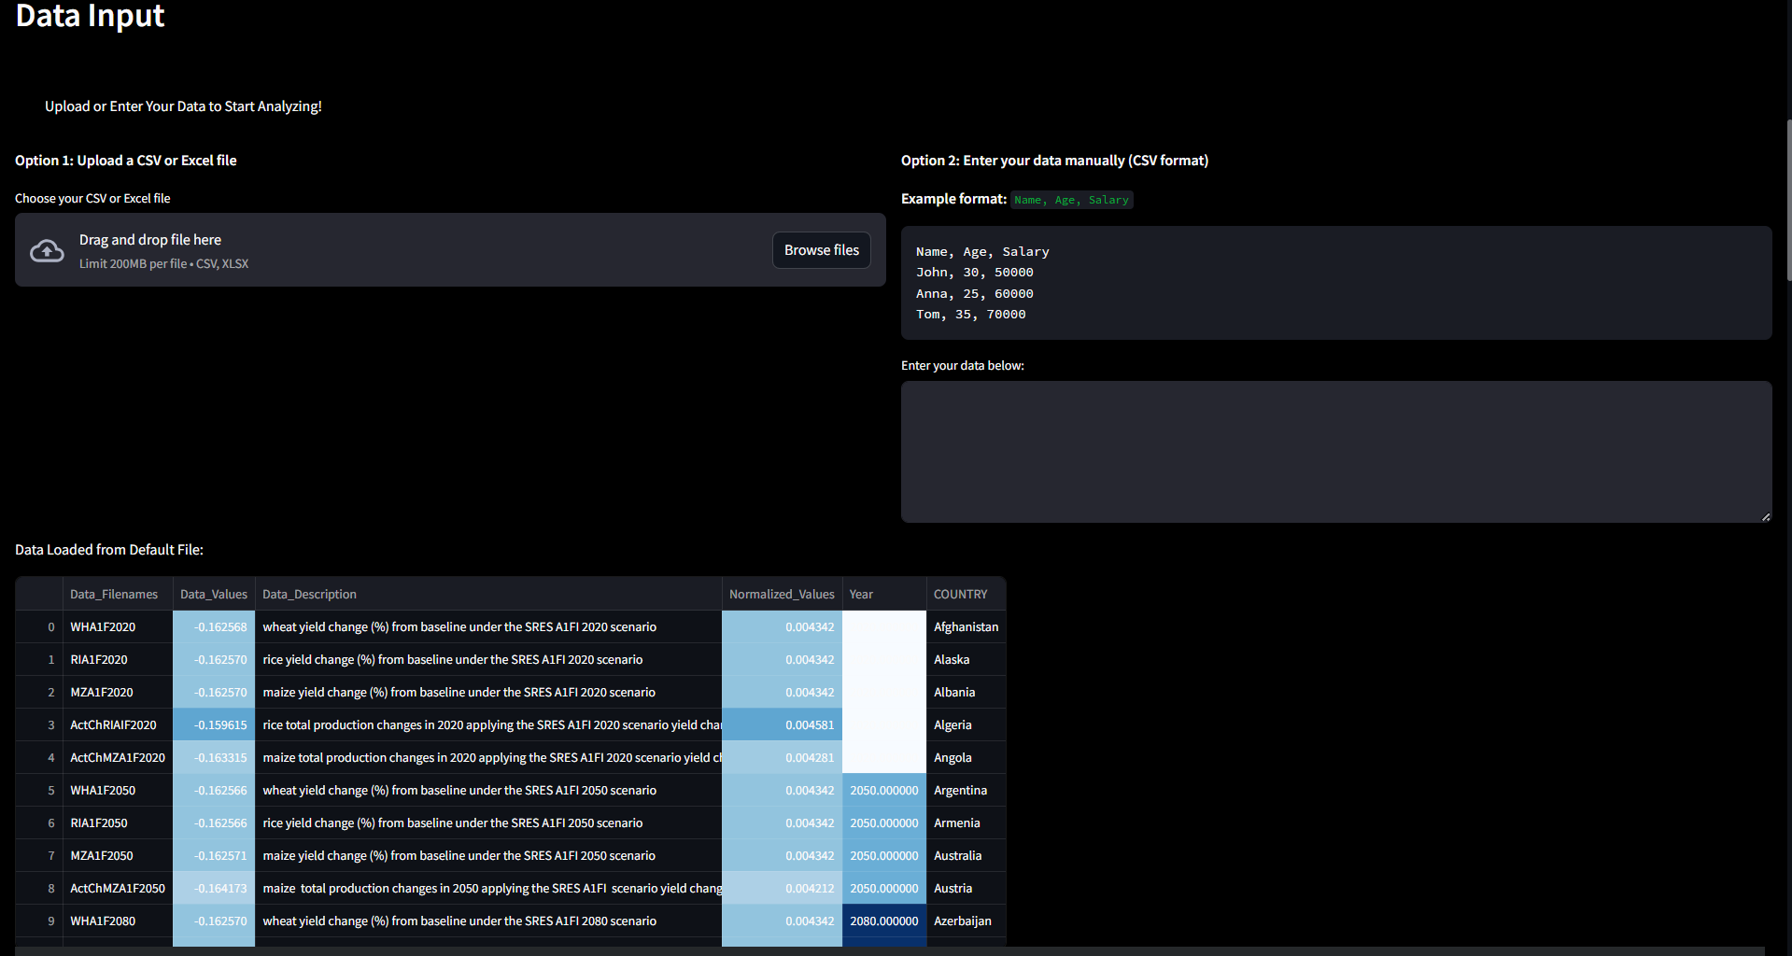

**2. Data Input Section**

In the Data Input Section, users are given two primary options for inputting their data:

* **File Upload:**

Users can easily upload their CSV or Excel files. Once uploaded, the application displays the data in a user-friendly table format, allowing for quick verification and initial analysis. This feature ensures that users can immediately begin analysing their data without cumbersome setup processes.

* **Manual Data Entry:**

For those who prefer to input data directly, this section includes a text area where users can enter data in a specified format (e.g., Name, Age, Salary). An example format is provided to guide users, making it accessible even for those who may not be familiar with data formats.

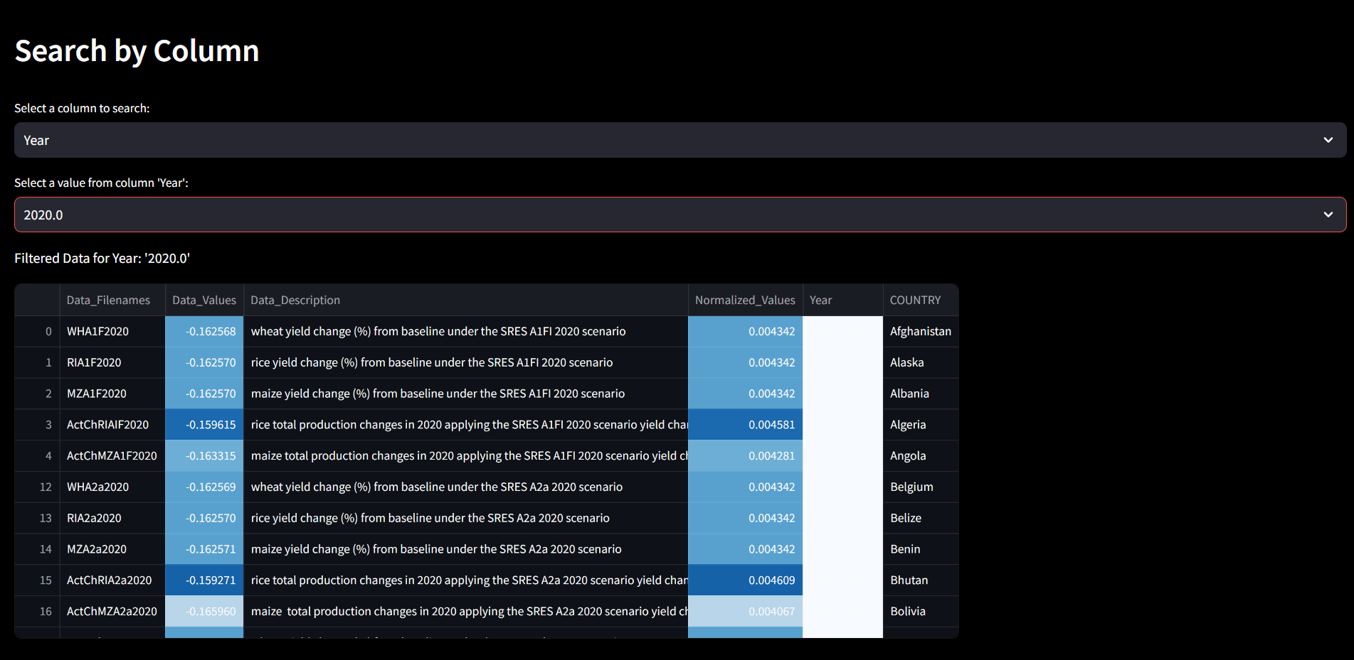

**3. Search Data Section**

The Search Data Section enables users to filter their data dynamically. This feature is particularly useful for analysing large datasets. Users can:

* **Select a Column:**

They choose from the available columns in their dataset, facilitating focused analysis based on specific attributes.

* **Select a Value:**

Once a column is selected, users can pick a specific value from that column to filter the dataset. The filtered results are displayed in a table, allowing users to hone in on specific data points of interest.

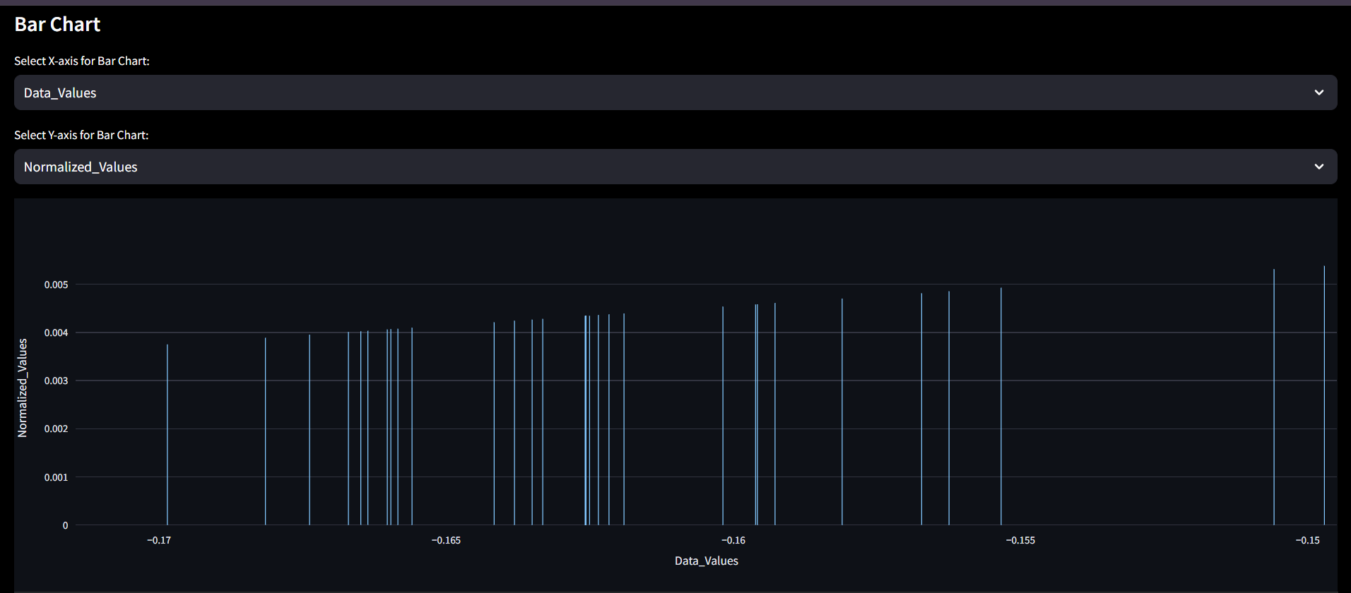

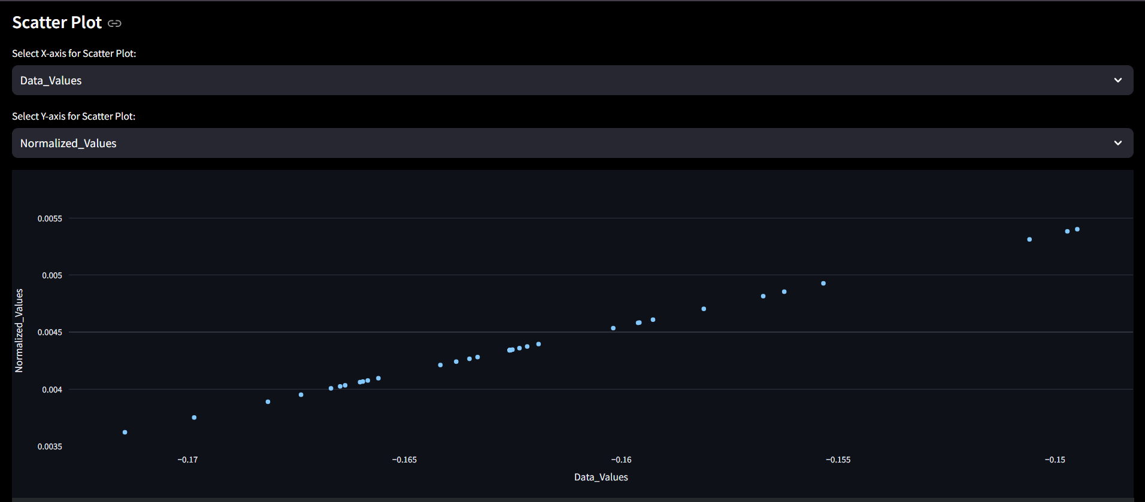

**4. Visualizations Section**

The Visualizations Section provides users with tools to create meaningful graphical representations of their filtered data. This section includes:

* **Pie Chart:**

Users can create pie charts from categorical data, helping visualize the distribution of different categories within their dataset.

* **Bar Chart:**

This feature allows users to select numeric columns for the x and y axes, providing a way to visualize relationships and comparisons between different data points.

* **Scatter Plot:**

Users can create scatter plots to explore correlations between two numeric variables, offering insights into trends and patterns in the data.

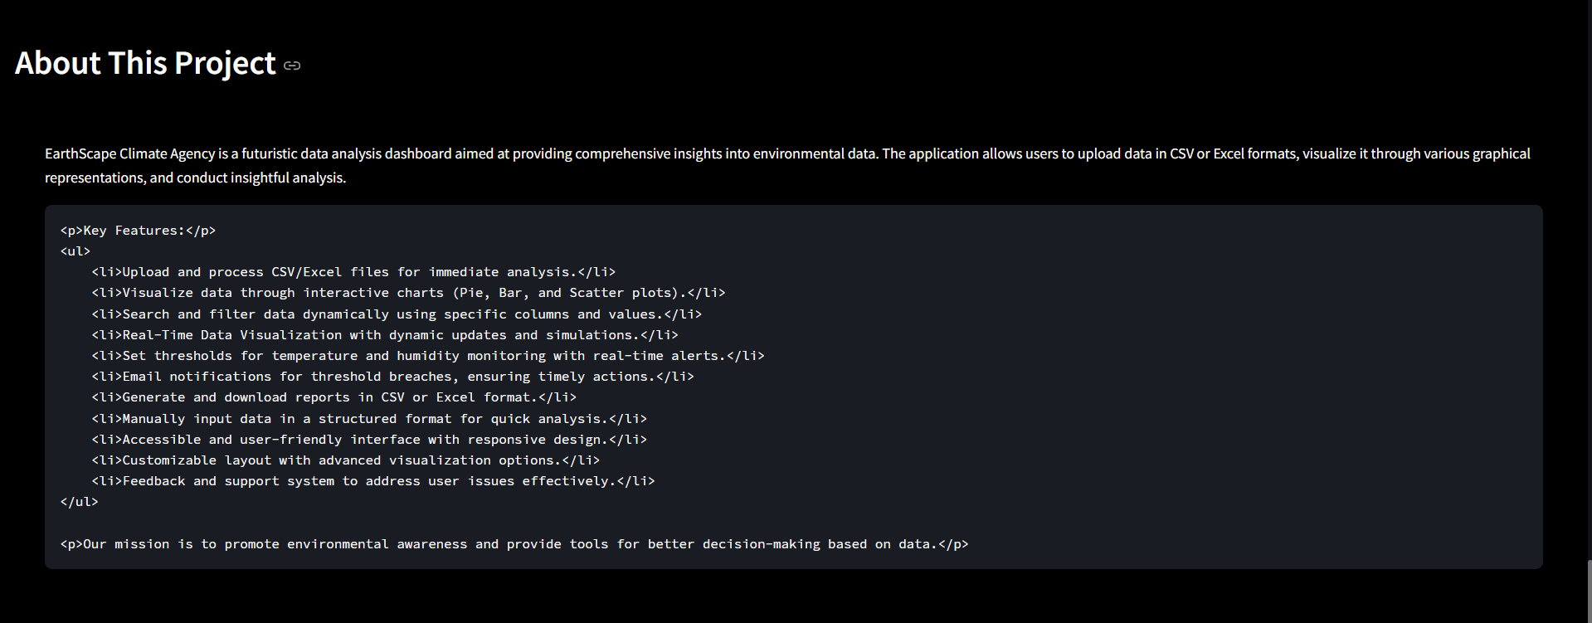

**5. About Section**

The About Section gives users an overview of the EarthScape project, outlining its objectives and significance. It includes:

* **Project Overview:**

A description of the dashboard’s purpose, focusing on its role in promoting environmental awareness and providing essential tools for data analysis.

* **List of Features:**

A summary of key functionalities, such as the ability to upload and process files, visualize data through interactive charts, and perform dynamic searches. This section highlights the user-friendly design and accessibility of the dashboard.

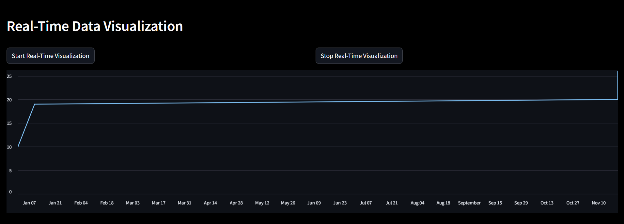

**Real-Time Data Visualization Dashboard**

The image provided represents a dashboard designed for real-time data visualization. This dashboard allows users to monitor and analyze data trends dynamically as they are updated in real-time. It provides an interactive interface for controlling the visualization process and a clean design to make data analysis intuitive and user-friendly. Below is a comprehensive explanation of its components, functionality, and significance.

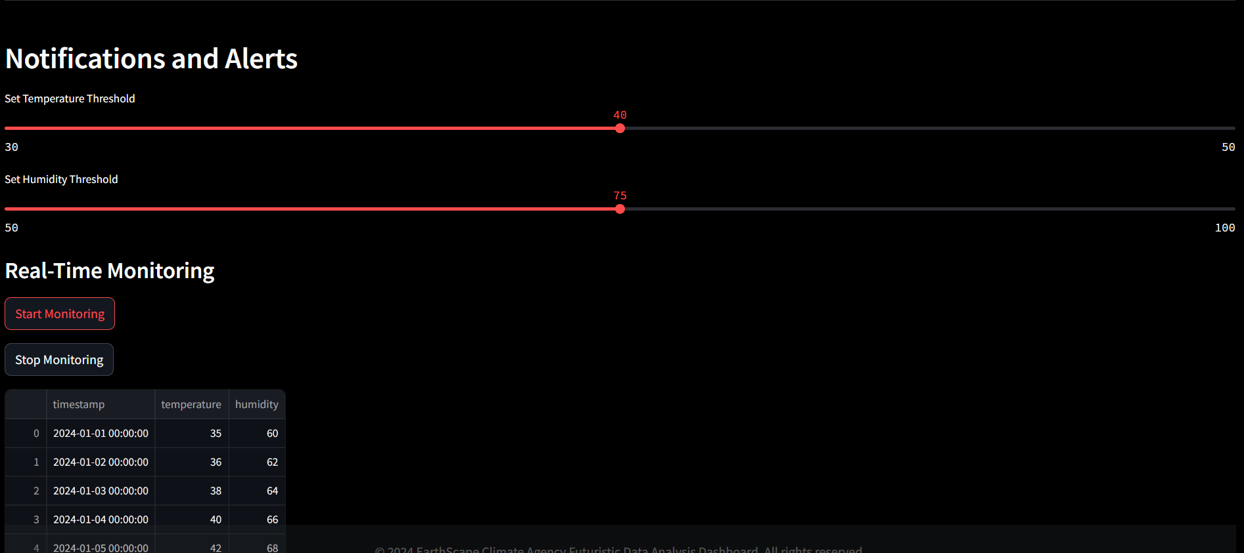

**Dashboard for Notifications and Alerts with Real-Time Monitoring**

The provided dashboard focuses on **real-time monitoring** and dynamic threshold-based notifications. It allows users to set specific thresholds for environmental factors like temperature and humidity while enabling real-time data updates and monitoring. Here's a detailed explanation of its structure, functionality, and significance.



**Report Generation**

In the Generate Report section of the EarthScape Data Analysis Dashboard, users can easily download the filtered data they have processed. This feature allows for seamless exporting of data in both CSV and Excel formats, enhancing the usability of the application.

**Key Features:**

* **Download as CSV**:

Users can click the "Download Report as CSV" button to export the current filtered dataset in CSV format. This is particularly useful for those who prefer working with data in spreadsheet applications or for further analysis.

* **Download as Excel**:

Users have the option to download the data as an Excel file by clicking the "Download Report as Excel" button. This allows for better formatting and the ability to utilize Excel's advanced features.

**Usage:**

1. **Filtered Data Requirement**:

Before generating a report, users must first upload or enter their data and apply any desired filters. The report will be generated based on the currently displayed filtered dataset.

1. **Download Links**:

Once the user clicks on the respective download button, a link will be generated. Clicking this link will initiate the download of the report in the chosen format.

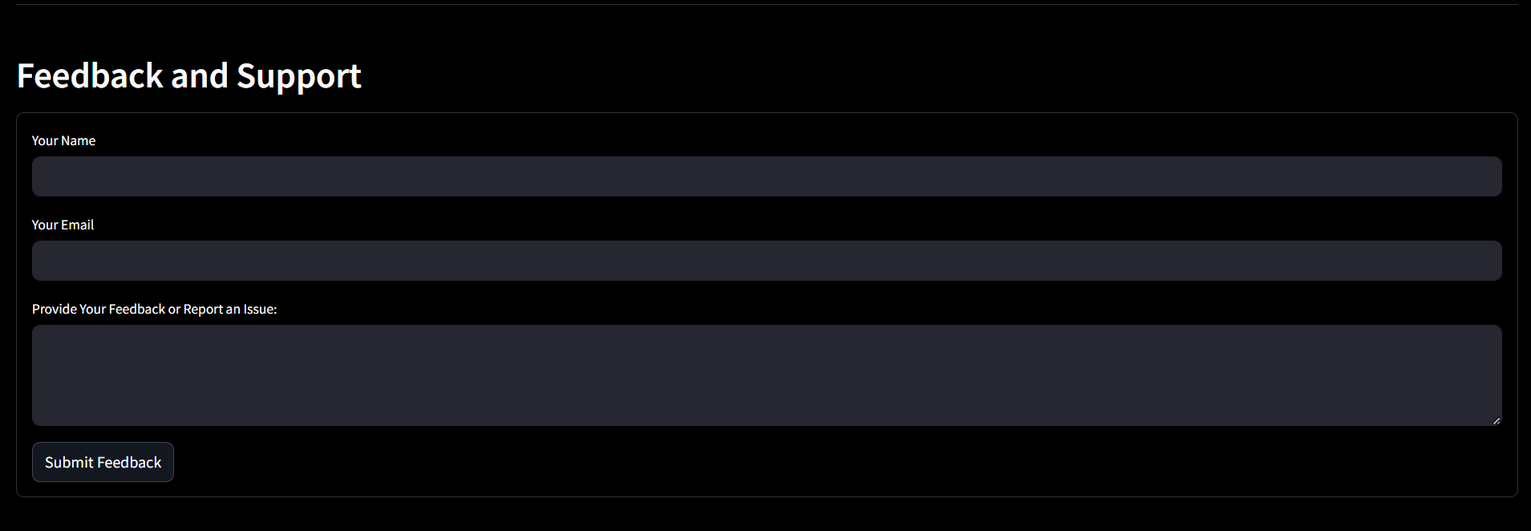

**Feedback and Support Dashboard**

The provided image showcases a **Feedback and Support** interface designed to collect user input for improving the system, addressing user concerns, and resolving issues. Below is a detailed description of the form and its functionalities:

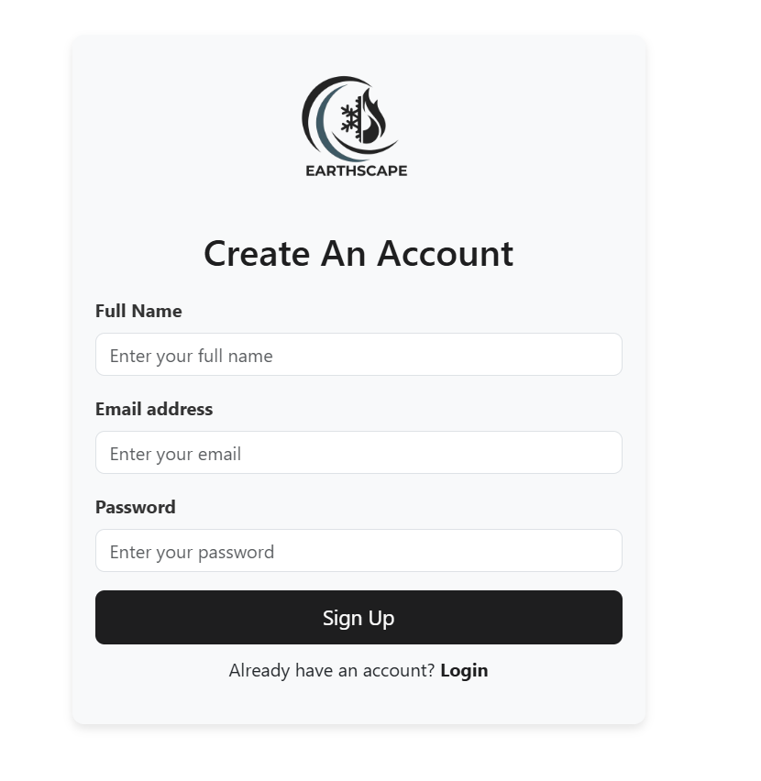



**Earthscape Login & Signup Details:**

1. **Login**: Allows existing users to access their Earthscape accounts using their registered email and password.
2. **Signup**: Enables new users to create an account by providing their name, email, and password, ensuring secure access to Earthscape services.

**Tableau Designing Phase**

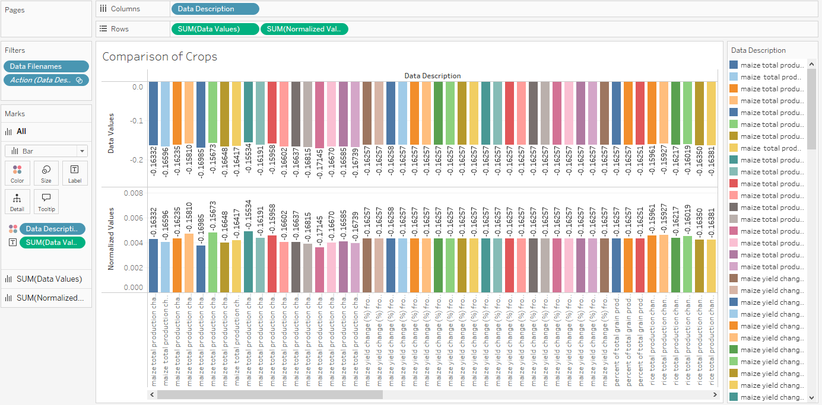

**Comparison of Crops**: This visualization likely compares different crop yields or performance metrics across various conditions or treatments.

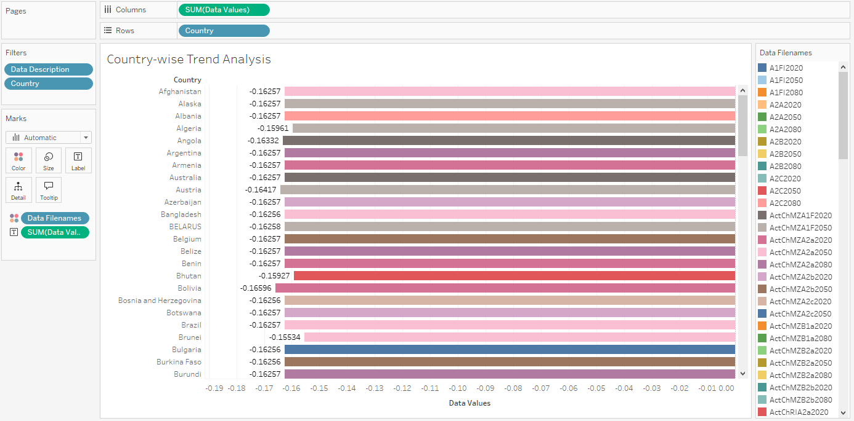

**Country Wise Trend Analysis**: This image is probably analyzing trends in crop yields, weather patterns, or environmental impacts on agriculture across different countries.

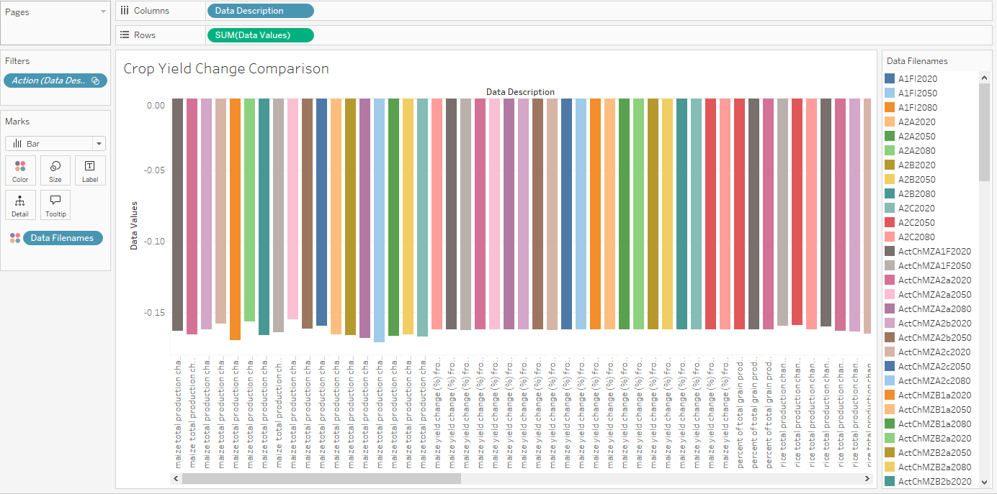

**Crop Yield Change Comparison**: This graph might show the changes in crop yields over time, possibly under different environmental stresses or management strategies.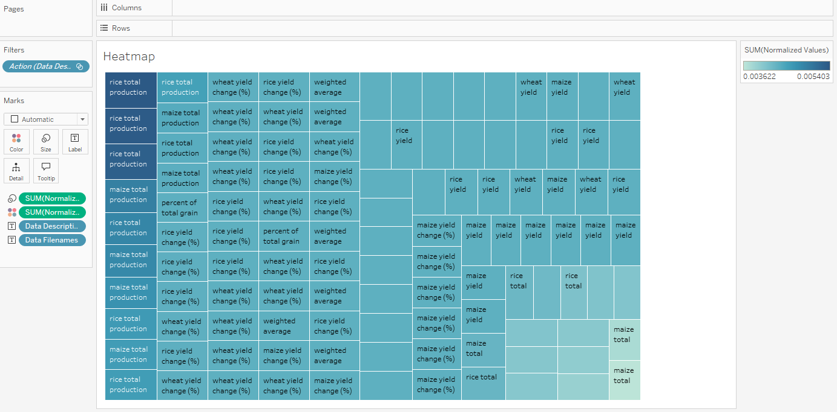

**Heatmap**: Typically used to represent data density or intensity in different regions, this could detail temperature variations, precipitation patterns, or other climatic factors affecting agriculture.

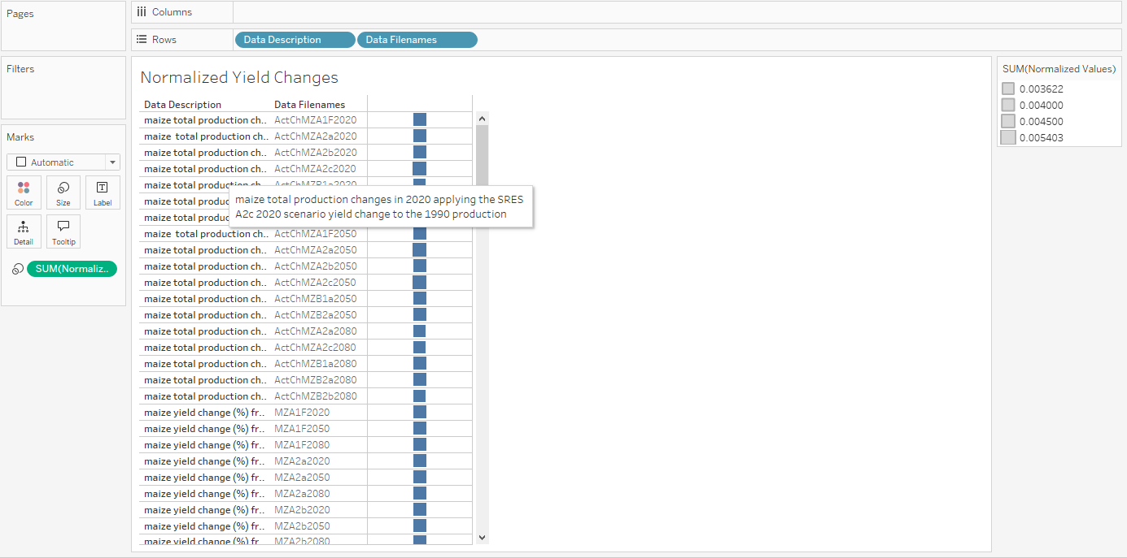

**Normalized Yield Changes**: This graph could depict yield changes normalized against a baseline, highlighting deviations or trends important in studying impacts of climate change or agronomic interventions.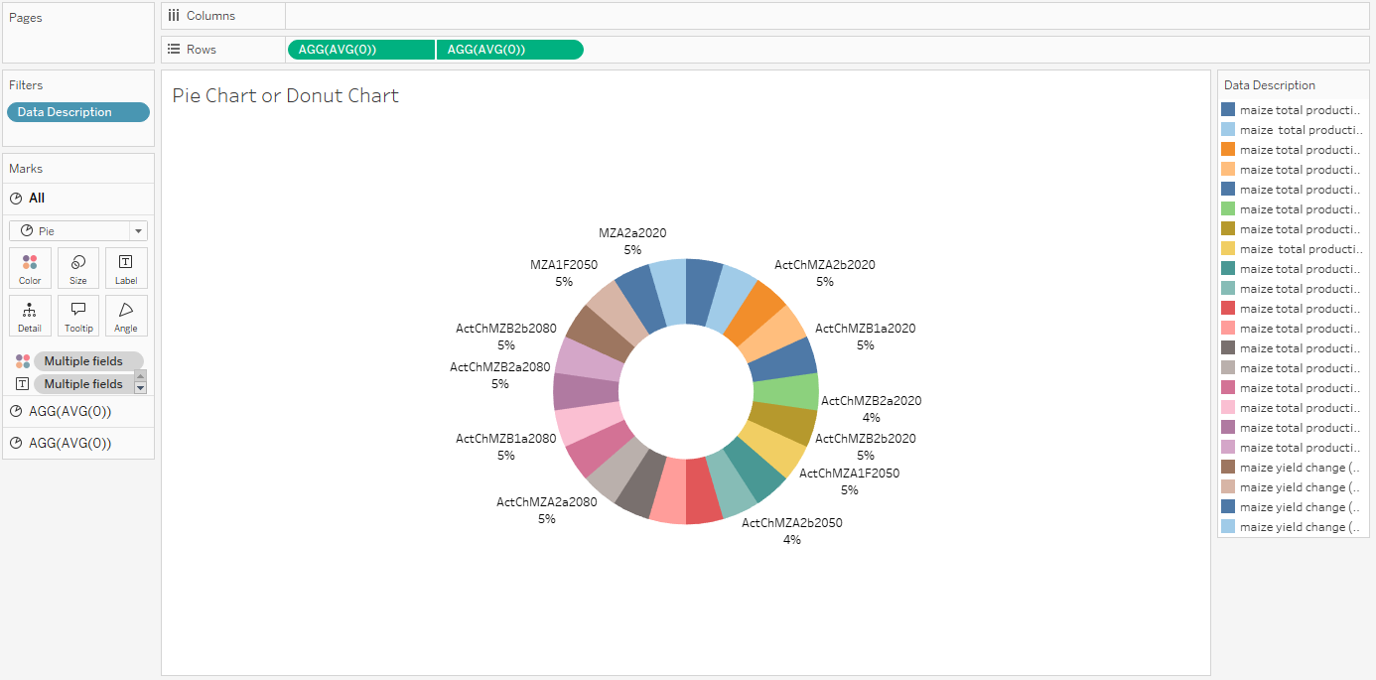

**Pie Chart or Donut Chart**: This visualization would break down percentages of different categories, such as types of crops, environmental impacts, or resource usage.

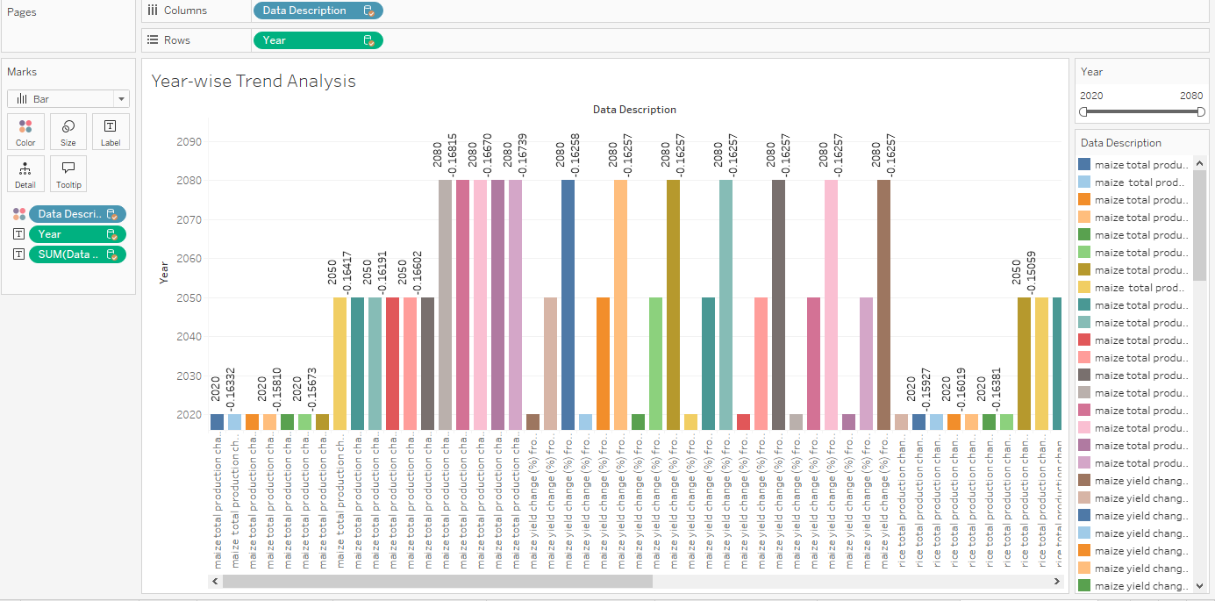

**Year Wise Trend Analysis**: This chart is likely tracking the progression of a particular agricultural or environmental metric over the years, showing trends that could be critical for long-term planning and strategy.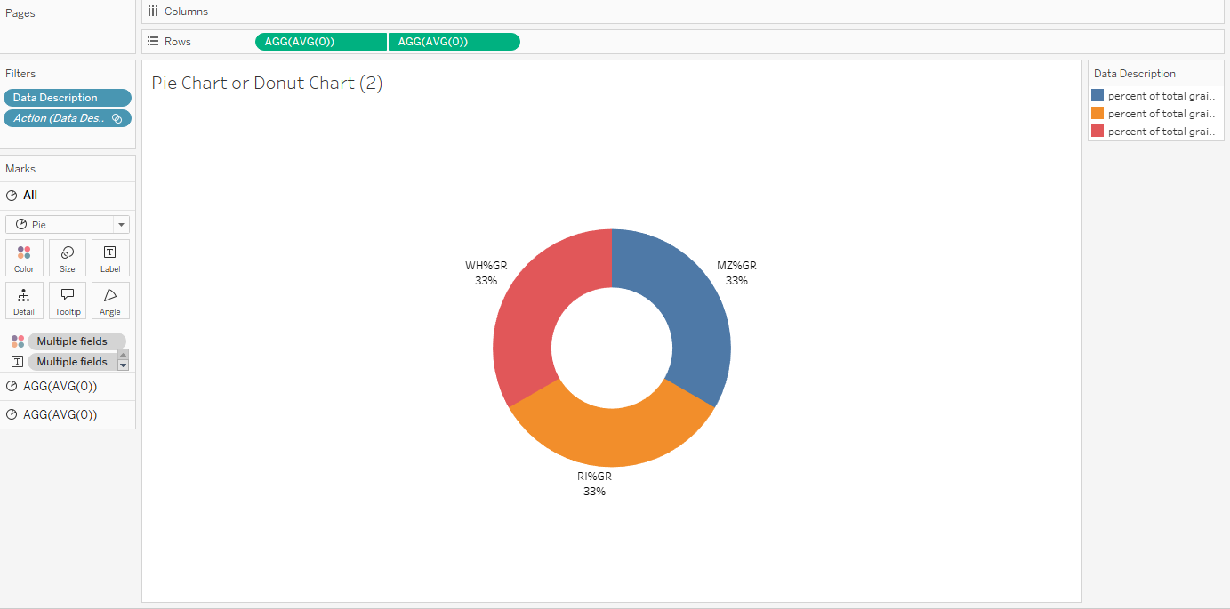

**Pie or Donut Chart**:

* This chart seems to represent three categories, labeled "WH%GR," "MZ%GR," and "RI%GR," with each sector accounting for 33%. It might depict the percentage distribution of different grain types, possibly "Wheat," "Maize," and "Rice," based on color legend and labels.
* The chart is likely showing the percentage of total production for each grain type.

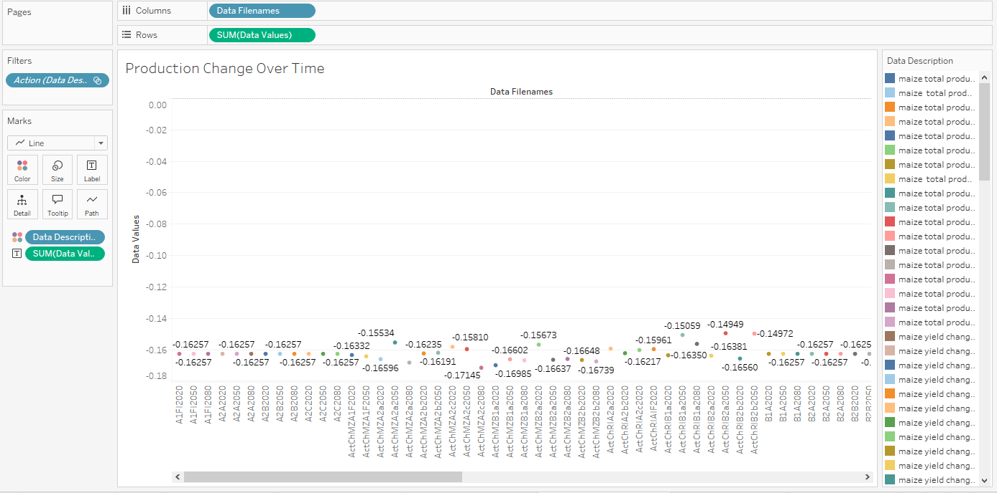

**Production Change Over Time (Line Chart)**:

* This chart visualizes the changes in production values over a period (likely years or specific time frames).
* The X-axis lists "Data Filenames," which could represent different scenarios or models over time.
* The Y-axis ("Data Values") shows the change in production (values are negative, which suggests a reduction in production).
* The color legend represents different types of grains or datasets related to grain production, with maize being the most notable.

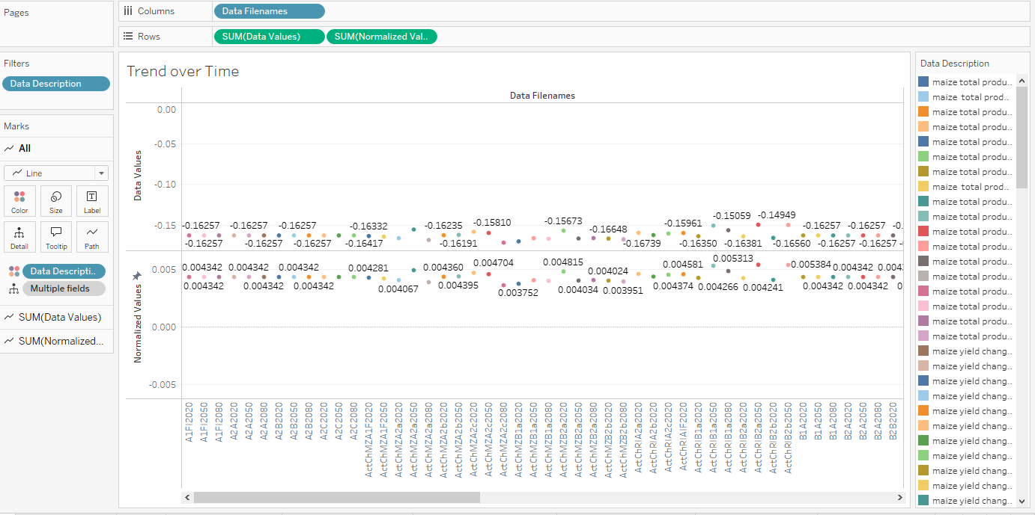

**Trend Over Time (Line Chart)**:

* This chart appears similar to the previous one but with two sets of data visualized: "Data Values" and "Normalized Values."
* The top portion represents the same production changes over time as seen in the second chart.
* The lower portion ("Normalized Values") shows more subtle fluctuations, likely adjusted or normalized to remove variations and focus on trend insights.
* Each colored dot represents a specific time point for a different grain type or production model (based on the color legend).

**Model Training Using Jupyter**

**1. Data Splitting:**

* The data is split into training and testing sets using an 80/20 split (`train_test_split`). `X_train` and `X_test` represent the feature sets for training and testing, while `Y_train` and `Y_test` represent the target values.

**2. Model Selection:**

* Three machine learning models are defined:
* RandomForestRegressor: Used for predicting continuous values.
* SVR (Support Vector Regressor): Another regression model used to predict continuous values.

Naive Bayes: Typically used for classification tasks. In this case, the continuous target variable `y_train` is binned into categories using `pd.qcut()` so that Naive Bayes can work with it.

**3. Model Training:**

The models are trained on the training data:

* For Naive Bayes: The target variable (`y_train`) is binned into 4 discrete categories before training because Naive Bayes requires categorical targets.
* For Random Forest and SVR: These models are trained directly on the unmodified continuous data (`y_train`).

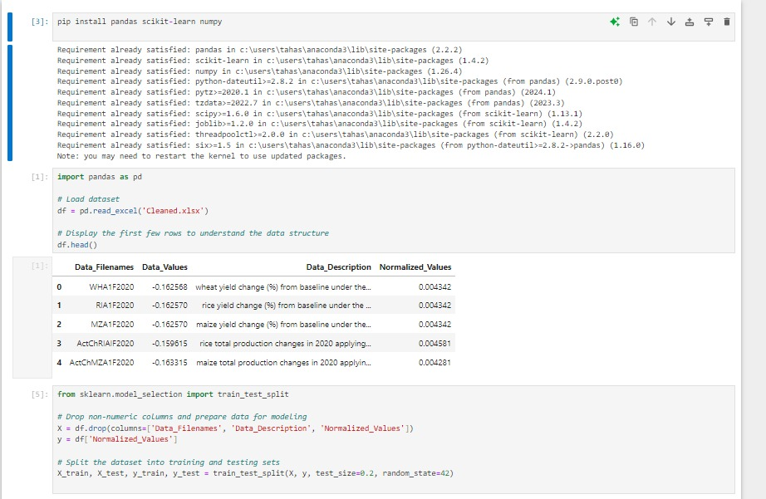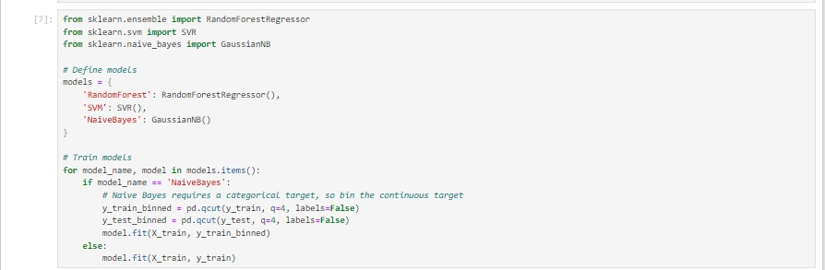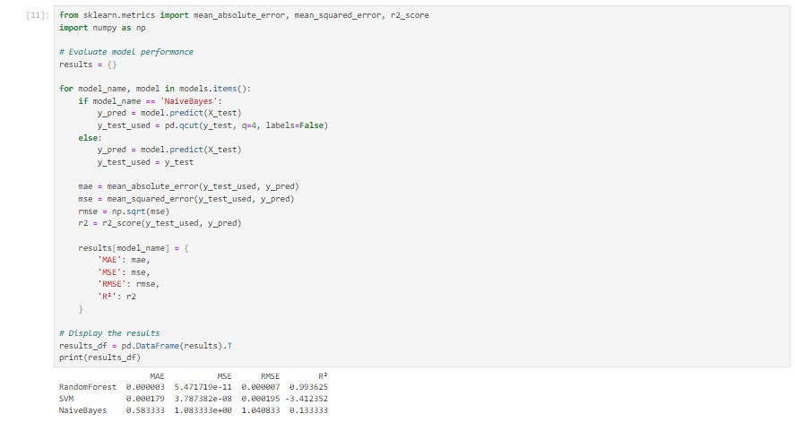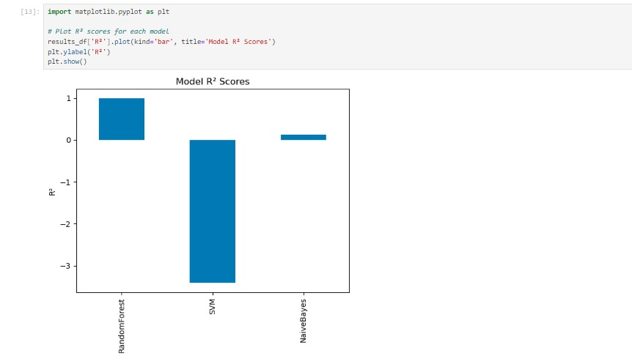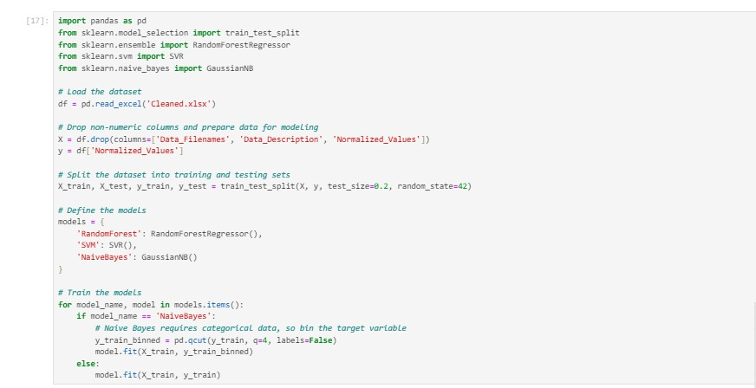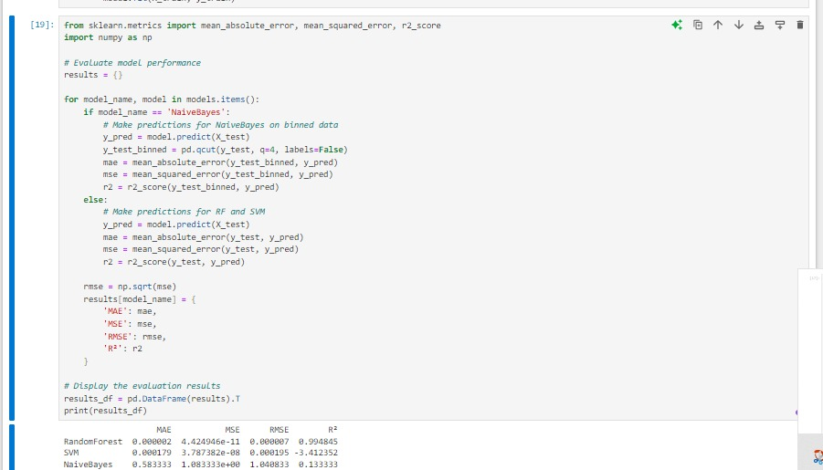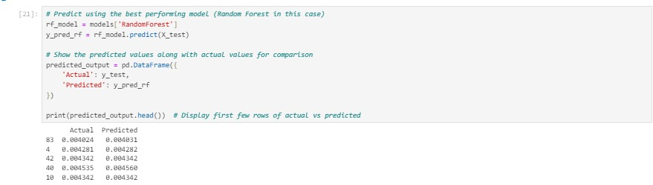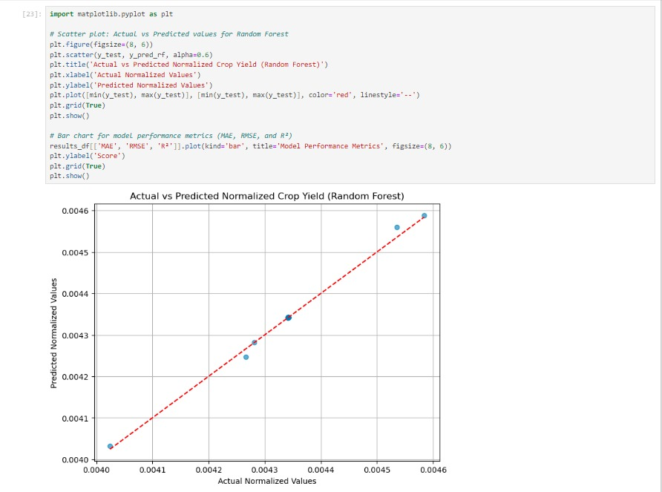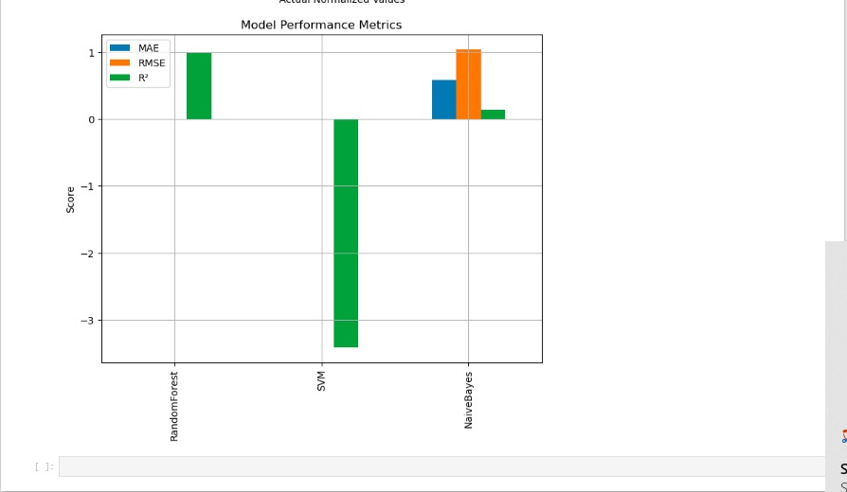

**RandomForestRegressor and SVR predict the continuous target values.**

Naive Bayes requires a categorical target, so the continuous target is converted into categories by binning before training.

After training, the models can be evaluated or used to make predictions on the test data (`X_test`).

**Home Page**

**Environmental Data and Crop Analysis Dashboard on Home Page:**

* The home page now prominently displays your environmental and agricultural data analysis, making it easy to monitor the latest climate trends and crop yields. This centralized dashboard ensures you can quickly access the most relevant data without navigating through multiple sections.
* You can view current environmental conditions, track crop growth stages, and receive alerts about potential climatic threats, all from one place. Additionally, set goals for sustainable practices and track their progress seamlessly.

**Generate Reports and Export Data:**

* With EarthScape, you can generate comprehensive reports detailing climate trends, crop performance, and sustainability metrics. This feature allows for a deeper understanding of environmental impacts on agriculture.
* You have the flexibility to customize reports to include specific data points and select the time period you're interested in. Whether you're preparing a presentation, submitting findings to stakeholders, or conducting detailed analyses, these tailored reports provide the insights you need.
* Exporting data is more streamlined with options to save information in CSV format, facilitating easy integration with other software tools like Python for further analysis or sharing with research teams.
* Whether you're tracking seasonal changes, evaluating the effectiveness of agricultural interventions, or sharing insights with policy makers, these enhancements empower you to manage and share your environmental data more effectively.



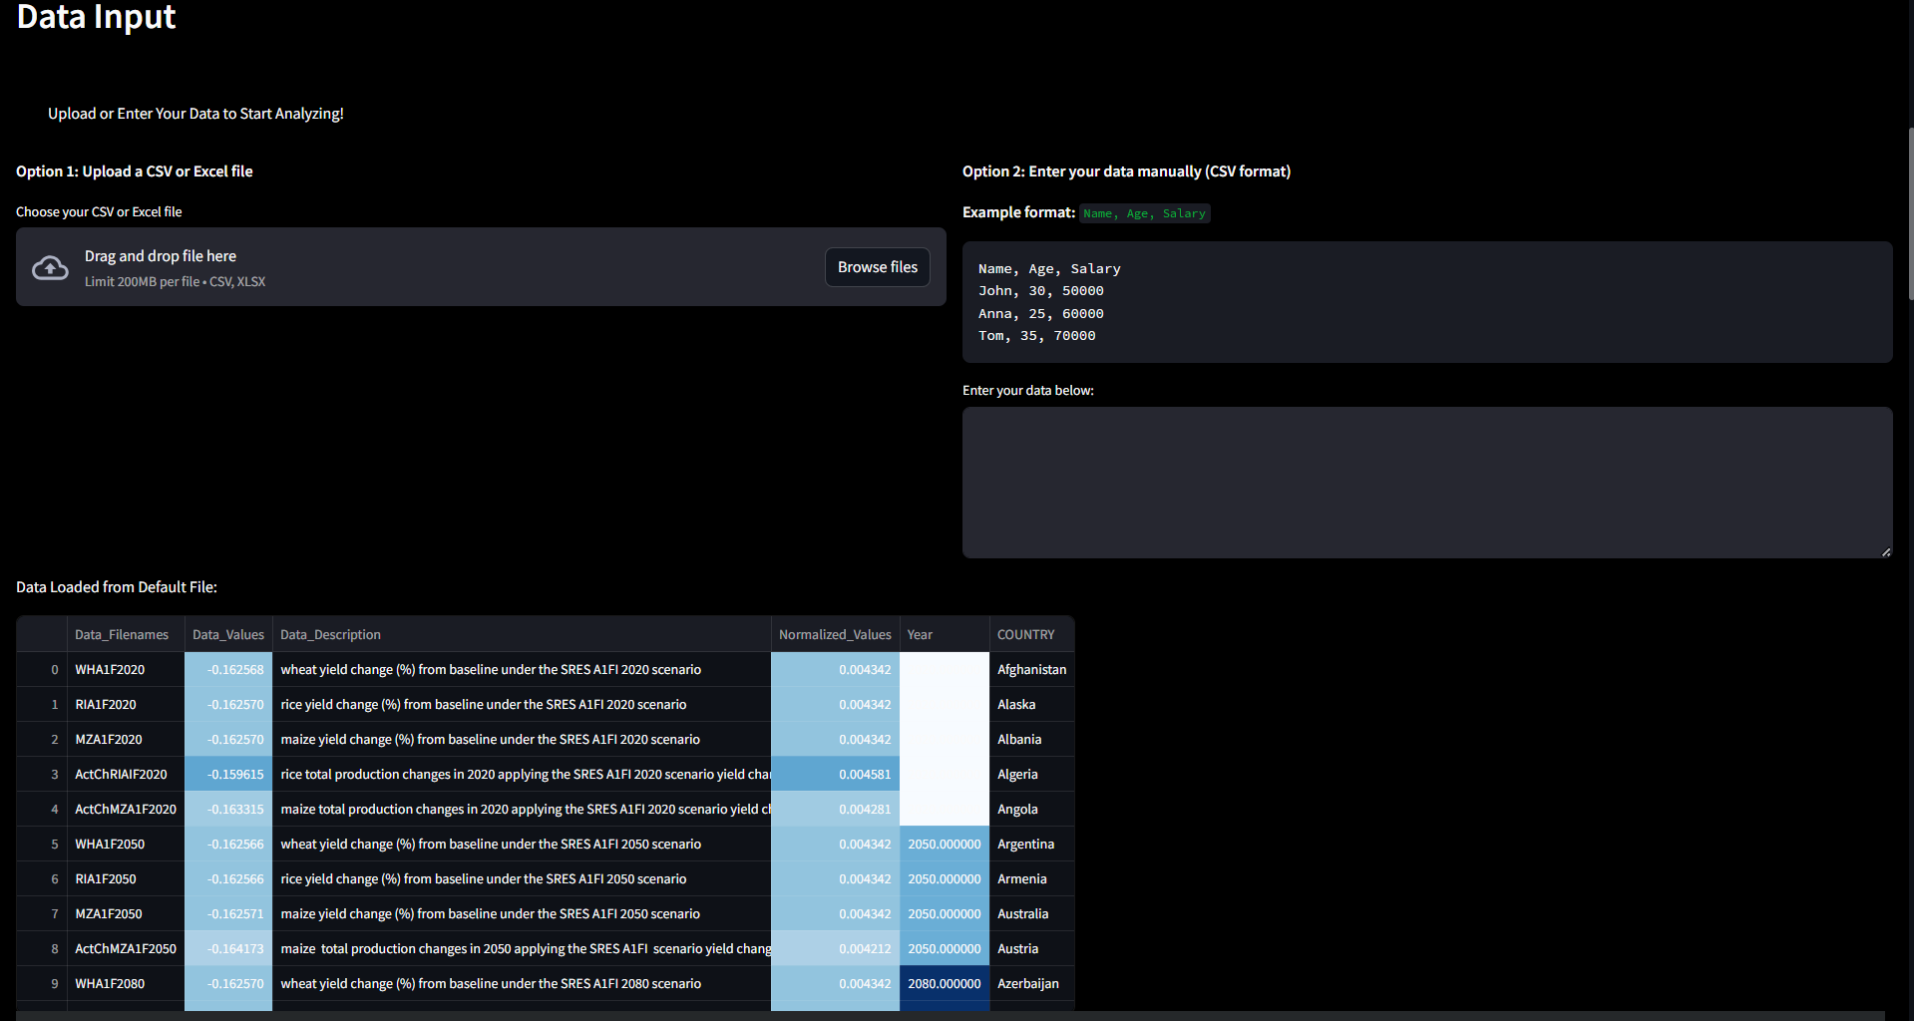

* **System Flow Chart.**

1. **Main flow chart**

The following below the flow chart of the system which is describe below

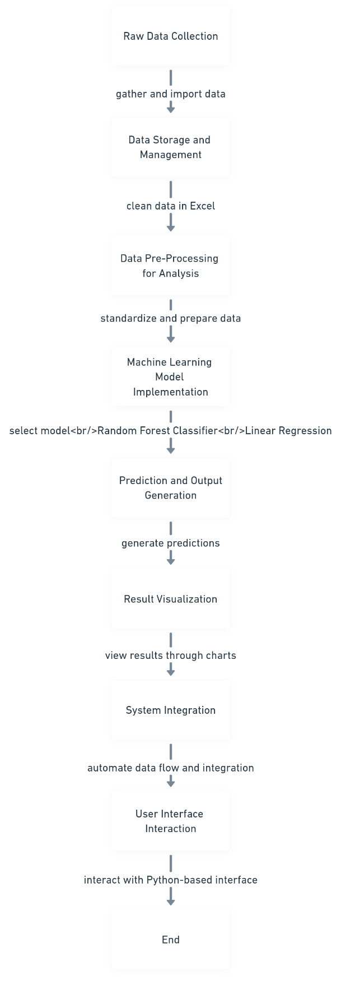

1. **Detail flow chart**

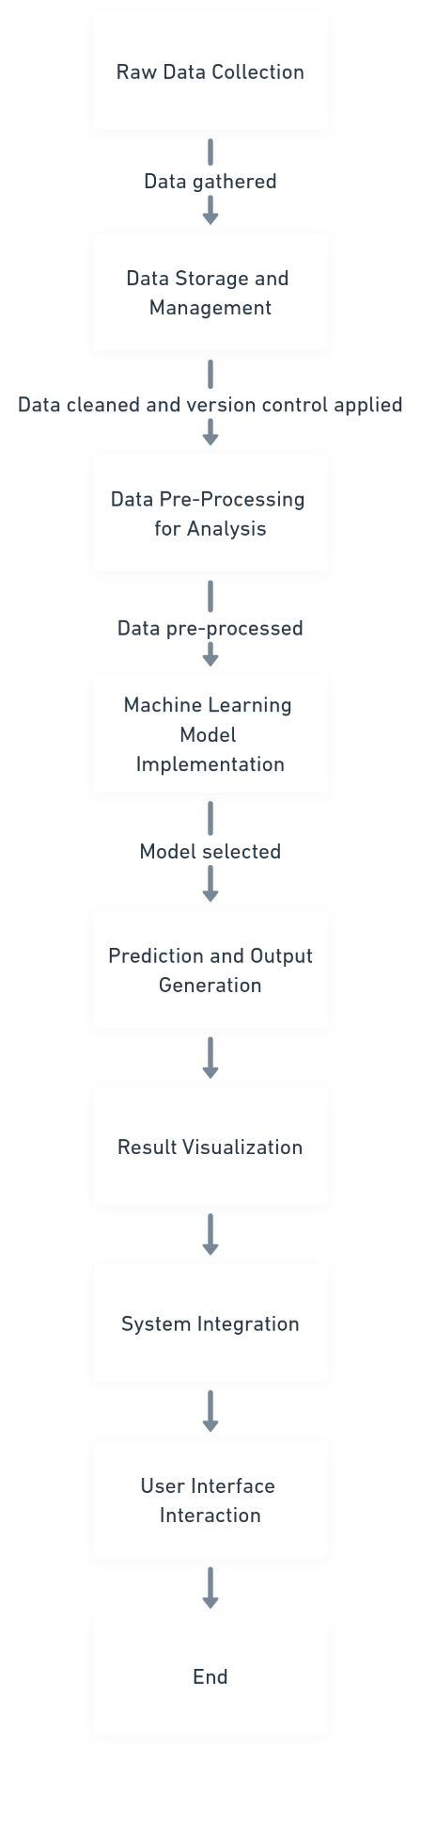

1. **User system flow**

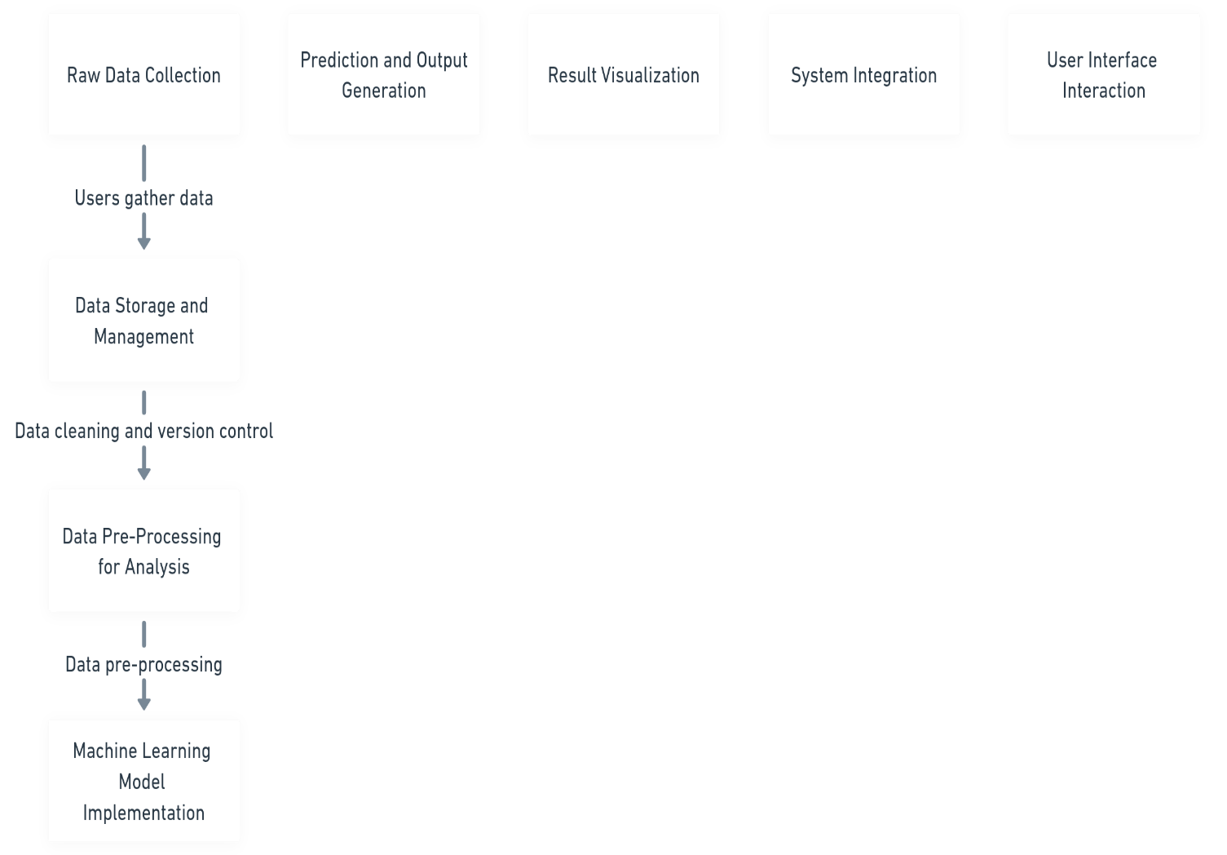

* **Data flow Diagram**

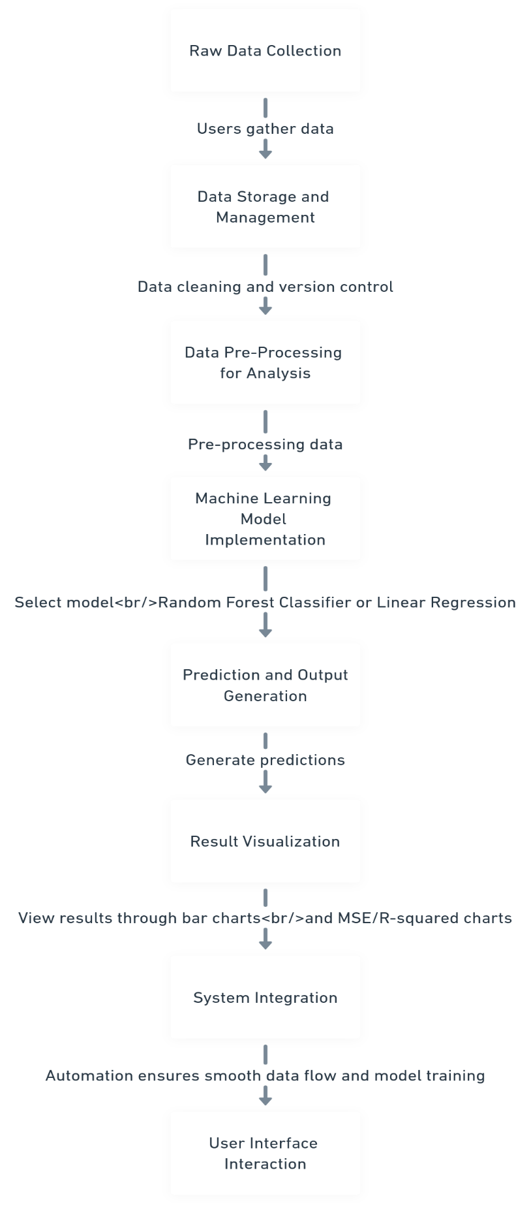

* **User Journey Map**

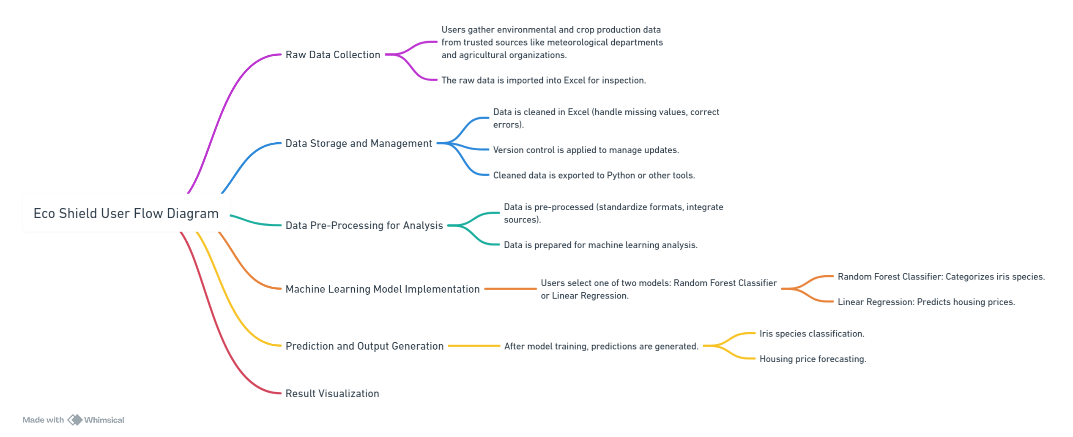

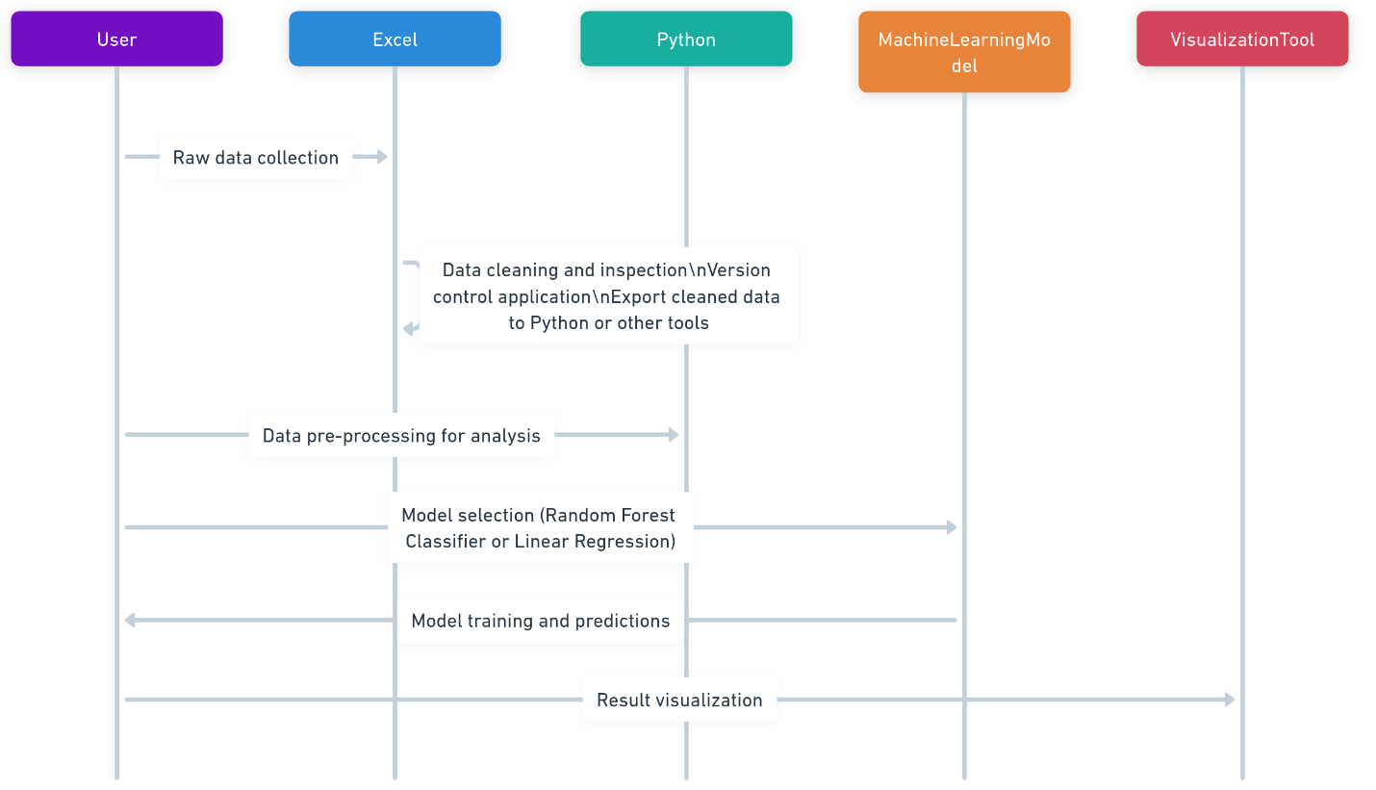

**Source Code**

import streamlit as st

import pandas as pd

import os

import seaborn as sns

import matplotlib.pyplot as plt

import plotly.express as px

# Streamlit app title

st.title("Advanced Excel and CSV File Analysis Dashboard with User Prompt")

# Specify the path to the folder where the default Excel file is located

folder_path = "data"  # Adjust this path based on the actual location

file_name = "Cleaned_Save_Planet_Dataset_All (1).xlsx"  # Default file name

# Construct the full file path

file_path = os.path.join(folder_path, file_name)

# Initialize the DataFrame variable

df = None

# Function to read Excel file

def load_excel(file):

    try:

        return pd.read_excel(file)

    except Exception as e:

        st.error(f"Error loading Excel file: {e}")

        return None

# Function to read CSV file

def load_csv(file):

    try:

        return pd.read_csv(file)

    except Exception as e:

        st.error(f"Error loading CSV file: {e}")

        return None

# Check if the default file exists

if os.path.exists(file_path):

    # Load the default Excel file into a Pandas DataFrame

    df = load_excel(file_path)

    if df is not None:

        st.write("Using the default file from the specified path.")

# Allow the user to upload a file (supports .xls, .xlsx, .xlsm, .xlsb, and .csv)

st.write("Or you can upload an Excel or CSV file:")

uploaded_file = st.file_uploader("Upload a file", type=["xlsx", "xls", "xlsm", "xlsb", "csv"])

# If the user uploads a file, determine the file type and read it accordingly

if uploaded_file is not None:

    file_extension = uploaded_file.name.split('.')[-1].lower()

    if file_extension in ["xls", "xlsx", "xlsm", "xlsb"]:

        df = load_excel(uploaded_file)

    elif file_extension == "csv":

        df = load_csv(uploaded_file)

    if df is not None:

        st.write("Using the uploaded file.")

# If neither a default file nor an uploaded file is available, show an error

if df is None:

    st.write(f"No file found at {file_path} and no file uploaded. Please upload an Excel or CSV file to proceed.")

    st.stop()  # Stop the app until a file is provided

# Display the DataFrame in Streamlit

st.write("### Data from the file:")

st.dataframe(df)  # Display data as a table

**Compiled Code**

* **EarthScape Climate Data Tracker**

The EarthScape Climate Data Tracker is a powerful tool designed to help you monitor and analyze climate-related data for environmental insights and agricultural impact. With features such as generating detailed reports and exporting data, it provides users with a comprehensive view of climate trends and their influence on crop yields. Utilize the search functionality to find specific data sets or trends, making it easier to track patterns over time.

Each data entry offers detailed information, including country or region, crop type, year-wise production trends, climate factors (such as temperature, rainfall, CO2 levels), and other relevant notes. You can edit or delete entries as needed, ensuring your data remains accurate and up-to-date. The pagination feature allows you to seamlessly navigate through your stored data, whether you are reviewing trends from past years or current forecasts.

Whether you're an environmental researcher, agricultural expert, or policymaker, the EarthScape Climate Data Tracker empowers you to make informed decisions for sustainable development and agricultural planning based on reliable data.

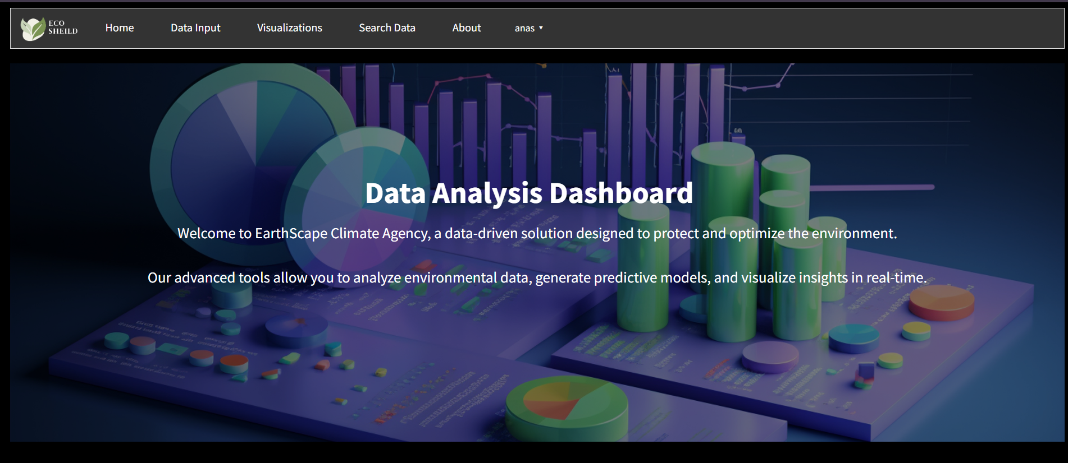



**Future Scope**

logiest like Artificial Intelligence (AI) and machine learning to revolutionize climate data analysis and agricultural sustainability. By leveraging AI, EarthScape can offer more precise and insightful predictions, making climate forecasting and crop yield optimization more accessible and efficient. Here are some ways EarthScape can evolve with AI integration:

1. **Personalized Climate Impact Predictions:**

AI algorithms can analyze vast sets of climate data—such as temperature fluctuations, rainfall patterns, CO2 levels, and soil conditions—to provide personalized predictions for specific regions or crops. This would allow farmers and policymakers to adapt quickly to changing environmental conditions, ensuring sustainable farming practices.

1. **Predictive Analytics for Crop Yields:**

Machine learning models could predict future crop yields based on past trends and current climate data, helping farmers optimize their planting cycles and manage resources more effectively. AI-driven analytics could also forecast potential agricultural risks like droughts, floods, or pest outbreaks.

1. **Real-Time Environmental Monitoring:**

AI-powered sensors could provide real-time monitoring of environmental factors such as soil moisture, air quality, and temperature. By continuously collecting data, EarthScape could offer real-time feedback and alerts, allowing farmers to make informed decisions on irrigation, fertilization, or other key agricultural practices.

1. **Climate Change Scenarios:**

AI can model various climate change scenarios, offering insights into how different levels of global warming or policy interventions might affect specific crops or regions over time. This would enable long-term planning and resource allocation to mitigate the negative impacts of climate change on agriculture.

1. **Sustainability Recommendations:**

AI could offer tailored recommendations to farmers and agribusinesses on sustainable farming practices, such as the best crops to plant in specific regions, optimal water usage, or the eco-friendliest fertilizers. These suggestions would be based on real-time data and long-term projections, ensuring that farmers can adopt more sustainable agricultural practices.

1. **Automated Data Management:**

Integrating AI would also improve the efficiency of data management in EarthScape. Automated systems could clean and pre-process large datasets, detect inconsistencies, and optimize the storage and retrieval of climate and crop-related information. This would streamline workflows and allow for faster analysis.

• **AI-Driven Visualizations**:

AI could enhance data visualizations within *EarthScape*, making it easier to interpret complex climate trends or crop yield predictions. These AI-generated insights could be delivered through dynamic dashboards, helping users quickly grasp critical information and make informed decisions.

• **Global Collaboration and Knowledge Sharing**:

AI could facilitate collaboration between researchers, governments, and farmers by creating an intelligent platform for sharing best practices, innovations, and lessons learned. This knowledge-sharing could boost global efforts in combating climate change's impact on agriculture.

Here’s how you can include specific login credentials for both admin and user in your document. This format makes it explicit and user-friendly:

**Admin and User Login Details**

This section provides the specific credentials and URLs for logging into the application as an admin or a user.

**1. Admin Login**

Credentials

Username: admin

Password: admin123

Login URL

**Admin Panel URL:**

http://127.0.0.1:8000/admin

Steps to Log In

Open a web browser and navigate to the Admin Panel URL.

Enter the following credentials:

**Username:** admin

**Password:** admin123

**Click Login.**

You will be redirected to the Django Admin Panel, where you can manage users, data.

**2. User Login**

Credentials

Login URL

User Login URL:

http://127.0.0.1:8000/login

**Steps to Log In**

Open a web browser and navigate to the User Login URL.

Enter the following credentials:

**Username:** anus2109d@aptechgdn.net

**Password:** @12345678

**Click Login.**

Upon successful login, you will be redirected to the user dashboard or home page, depending on the application’s configuration.

Notes

The credentials provided above are for testing purposes and should be changed in a production environment for security reasons.

If you cannot log in:

Ensure the username and password are entered correctly.

Contact the admin or check the Django Admin Panel for user account settings.

This format explicitly states the admin and user credentials and ensures it is easy to follow for anyone reading the document. Let me know if you’d like further refinements!

**Task Sheet**

|  |  |  |  |  |  |  |
| --- | --- | --- | --- | --- | --- | --- |
| **Project Ref. No:**  **Ep/Advertisement**  **Portal**  **Management**  **System** | | **Project**  **Title** | **Date Of preparation Of**  **Activity Plan** | | | |
| No. |  | **E**  **A**  **R**  **T**  **H**  **S**  **E**  **A**  **P**  **E** | Actual  Start Date | Actual  Days | Team-Mate  Name | Enrolment No: |
| 01. |  | **0**  **2**  **-**  **S**  **E**  **P T**  **-**  **2**  **0**  **2**  **5** | **0**  **2**  **-**  **O**  **C**  **T**  **-**  **2**  **0**  **2**  **5** | MUHAMMAD ANAS | 1415086 |
| 02. |  | MUHAMMAD TAHA | 1414158 |
| 03. |  | BHARTI | 1448007 |
| 0.4 |  | ANUM ASGHAR | 1406511 |

**Links**

* **Figma Link:**

[**https://www.figma.com/design/7N179nlDReqDi837C6edPh/EarthScape?node-id=0-1&t=NeZGGVjHXZU62090-1**](https://www.figma.com/design/7N179nlDReqDi837C6edPh/EarthScape?node-id=0-1&t=NeZGGVjHXZU62090-1)

* **Tableau Link:**

[**https://public.tableau.com/app/profile/muhammad.taha2039/viz/EarthScape/TrendoverTime**](https://public.tableau.com/app/profile/muhammad.taha2039/viz/EarthScape/TrendoverTime)

* **Dataset Link:**

**https://sedac.ciesin.columbia.edu/data/collection/crop-climate**